Field Report
on the
Development of recommendations for business skills training of drug sellers and owners and business financing as related to implementation of the Ugandan ADDO initiative
in Kibaale district

June 2009
JECON Consulting Group Ltd
By JECON Consulting Group Ltd
Plot 66 Kenneth Dale Drive, P.O. Box 32260, Kampala
Tel: +256-41-4378514, jecongroup@gmail.com info@jecongroup.com, Website: www.jecongroup.com

Table Of Contents
Contents Pages
List of tables 3
Executive Summary 4
Introduction and Background Information 5
Objective of the Assignment 6
Data and Methodology 7
Findings 9
- Overview of Kibaale District 9
- Drug shops back ground 9
- General management and environment of drug shops 10
- Business skills training needs 11
- Finance and finance needs 13
- Challenges faced by drug shop owners 15
- Financial institutions in Kibaale 15
Conclusion 17
- General remarks 17
- Business skills training 18
- Finance and financial needs 19
Recommendations 20
Annexure
- List of sampled drug shops
- List of financial institutions
- List of training institutions
- Questionnaire sample
- Terms of reference

LIST OF TABLES
Number Details Pages
Table 3.1 Summary of Financial Institutions Ratings 16
Table 5.1 Training Institutions Ratings 21

Executive Summary

The population of Uganda is approximately 30million with about 70% living in the rural and semi- urban areas. Research has revealed that unfortunately these people have limited access to quality pharmaceutical services. To a large extent Class C drug shops have tried to provide this service however, their mode of operation is rather restricted in terms of type and volume of products to satisfactorily meet the basic needs of the people.

To alleviate this problem Management Science for Health (MSH) in collaboration with National Drug Authority (NDA) and Pharmaceutical Society of Uganda (PSU) wants to intervene by developing a sustainable accredited drug dispensing outlet initiative in Uganda under the ADDO Program. The whole process will involve upgrading the drug shops to legally allow them stock and sell a limited number of essential drugs, equip owners with skills to sustainably manage their businesses and also enable them to access finance to grow their business. For this reason JECON was contracted to undertake a study to identify the required training needs of the shop owners and operators. The program will be piloted in Kibaale district.

JECON conducted a field study in the district during which 31 shop owners with their shop attendants were interviewed. Discussions were held with some financial institutions operating within the area and those interested in opening up centers. The findings concurred with previous studies; that the need to have these drug shops upgraded in terms of services and size was enormous. But there are gaps in business management skills like record keeping, governance, basic finance management and customer care. This report gives the methodology of study, detail of findings and recommended courses to be delivered.

1.0 Introduction and Background Information
Management Science for Health (MSH) is an NGO / project under the USAID program entrusted with the development and improvement of Pharmaceutical industry in Uganda with specific reference to the Drug dispensing.

MSH in collaboration with the National Drug Authority (NDA) and the Pharmaceutical Society of Uganda (PSU) wants to develop a sustainable accredited drug dispensing outlet initiative for Uganda that will be piloted and evaluated in Kibaale district.

The idea of establishing ADDO shops builds on MSH’s Strategies for Enhancing Access to Medicines (SEAM) Program, which, in collaboration with the government of Tanzania, launched the country’s successful accredited drug dispensing outlet (ADDO) program. Similar to the situation in Tanzania, drug sellers in Uganda’s Class C drug shops lack adequate business and dispensing skills, often do not have the financial resources to meet requirements of accreditation, and have limited knowledge in managing common illnesses in the community.

Although the Class C shops operate in an unregulated fashion, they are a necessary service to the majority of the population in the rural areas where there are no pharmacies. Even though these drug outlets are restricted to the sale of Class C medicines, assessments carried out in the districts of Kibaale and Mpigi revealed that they sell medicines beyond their legally-mandated scope in order to meet the genuine and basic needs of the rural population they serve.

The ADDO program therefore intends to upgrade these shops through an accreditation process of both the premises and the service providers. This will allow them to legally stock and sell a limited number of essential prescription medicines to serve the population.

In order to be profitable and sustainable in the long term without continuing donor support or subsidies, shop owners and dispensers must have appropriate business skills. They will also need to have access to financing that will allow them to meet requirements of an accredited shop and the increased level of medicines inventory that will have to be stocked and maintained.

MSH needs to know the exact position and level of these shop owners and dispensers so has to carry out the intervention as per the main objective. JECON Consulting Group is requested to propose the methodology of making MSH realize its objective.

1.2 Objective of the Assignment
The major objective of the assignment was to assist in the development of recommendations for business skills training and business financing as related to implementation of the Ugandan Accredited Drug Dispensing Outlets (ADDO) initiative.

Specifically the objectives of the consultancy included the following:
- Conduct assessments to determine financing needs and business skills training needs of Class C drug shop owners and drug sellers in Kibaale Uganda.
- Identify potential financing options for ADDO owners in order to upgrade their shop premises, increase inventory, and meet other requirements of being an accredited drug dispensing outlet. Among other options, micro financing and the role of SACCOs should be explored.
- Identify potential partners in the microfinance industry along with key micro financing implementation issues.
- Identifying potential partners in the business skills training industry and key implementation issues.
- Make recommendations regarding options for providing financing and business skills training to ADDO owners and drug sellers.

2.0 Data and Methodology
In carrying out the consultancy Jecon under took the following activities;
- Conducted three focus group discussions with the drug shop owners to assess financing and training needs.
- Met with eight financial institutions operating in Kibaale district :
- Met with the coordinator - supervisor of the drug shops in Kibaale district.
- Met with the following business skills training firms:
- Met with 31 drug-shop owners in Kibaale district.

2.1 Study Design
A study design using baseline and follow-up surveys was adapted to assist in the development of recommendations for business skills training and business financing as related to implementation of the Ugandan Accredited Drug Dispensing Outlets (ADDO) initiative.

31 out of the 93 class “C” drug shops were visited. The sampling was based on purposive depending on proximity and random selection. The 31 class “C” drug shops were located in four counties comprising of 17 sub-counties across the district. (Annexure i)

During the visit the following were done:
- Interviewing of shop owners and/ or shop attendants following a designed questionnaire.
- Reviewing of shop records
- Observed the shop and environment
- Conducted focus group discussions in areas where the shops were highly concentrated

Questionnaire and Indicators
The questionnaire was designed to collect data on; Institutional background, Product review, appropriateness of staffing, Tracking Financial activities, Financial Controls, Financial and operational sustainability, Education of owners and staffs, business skills training needs, and Financial needs. See annex ii.

Data was collected from at least 2 drug shops per every sub-county. A total of 31 class “C” drug shops were visited and data collected.

Focus Group Discussion
In assessing the financing and training needs of the drug shops, Jecon consulting Group Ltd met with groups of drug shop owners from the Kibaale district.

The focus group discussion was design to cover three main sections; general management and environment; accessibility of financing and business training needs. A number of questions were asked covering a number of topics. Open and free discussion was encouraged among the participants.
Focus Group Discussion in Session

Data collection
The study interview was conducted in four counties and 17 sub-counties from May 27th, to June 7th, 2009. A total of 31 Drug shops owners were interviewed individually and three focus Group discussion was carried out in three counties.

Data Analysis and Discussion
The health standards of Kibaale district, like any other remote district in Uganda, is still on the path to development, however there is need to hasten the pace. The relatively low living standards, the climatic conditions favoring high incidents of disease and poor infrastructure create an enormous requirement for increased, well stocked and sustainable drug shops within the district.
Part of Kibaale Town

Most of the shops owners have big plans. However, only a few of them are thinking of either expanding or upgrading their shops. Those are the only ones that are eligible for financial institution services. Unfortunately some shops have not shown interest of expanding/growth. They seem to be contended with their size and therefore may not need financial help to grow. They require more of savings awareness and entrepreneurship awakening.

3.0 Findings

3.1 Overview of Kibaale District
Kibaale district is located in mid-western Uganda with its headquarters about 220km from Kampala in an area often referred to as the “lost counties”. There are 3 main access routes into the district; one from Kyenjojo through Muhororo, Mubende through Kihumuro and from Hoima to kibaale. They are quite motorable but none of them is tarmac as yet. This makes transport to and within the district a challenge especially during the rain seasons.
Untarmac Road in Kibaale

3.2 Drug Shops Back Ground
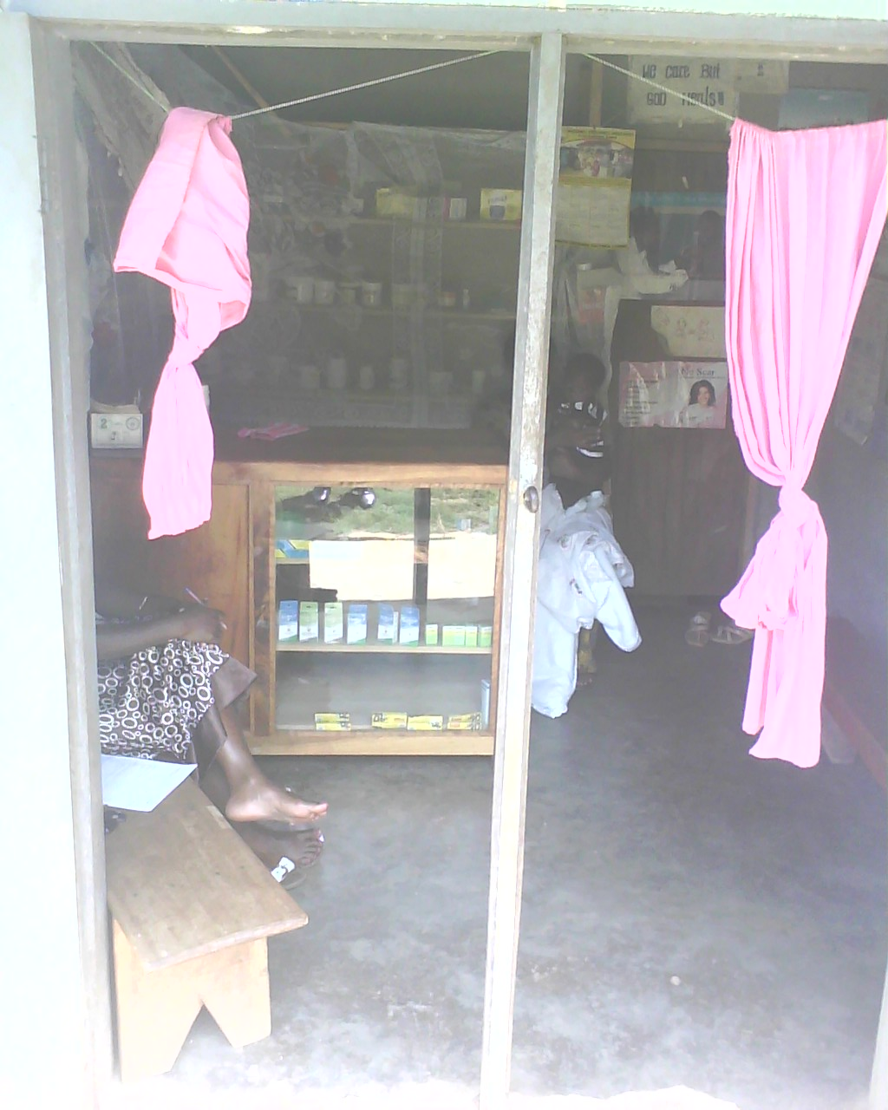
Most of the drug shops have been in existence from between 1 to 5 years and are owned by clinical officers, nurses and midwives. About 90% of the shops are operated by shop attendants who are mostly nursing assistants while the professional shop owners supervise once in a while, for example in the evenings or weekends.

Actually some shop owners admitted to having problems with monitoring the financial stand of their businesses.

Most owners have got no proper business plans and no targets to measure the performance of their business. However they believe that since they can continue buying drugs and other supplies while taking care of operative costs, their businesses are doing well. For example one owner said,
Stocked Drug Shop

“I do not know how much profits this shop brings in but since the stock is increasing, I believe it is doing well.”

Marketing is done by word of mouth as one satisfied client passes on information to the next person. These shops have 3 main areas of challenges:

- Direct competition – This is very high in the larger trading centers while there is hardly any in the remote areas.
- Indirect competition - There is also some degree of indirect competition from traditional medicine practitioners and pockets of illegal drug shops.
- Poverty in the local areas - Most people do not have enough money to buy the medicine and correct dosage that they need.

3.3 General management and environment

3.3.1 Commerce
With fertile land, flowing streams and dense forest cover agriculture produce is the main source of income for the people of Kibaale district. Unfortunately, most of it is still at subsistence level. There is trade and commerce in Kagadi and in a few other scattered towns but one does not get the impression of a “bustling” district.
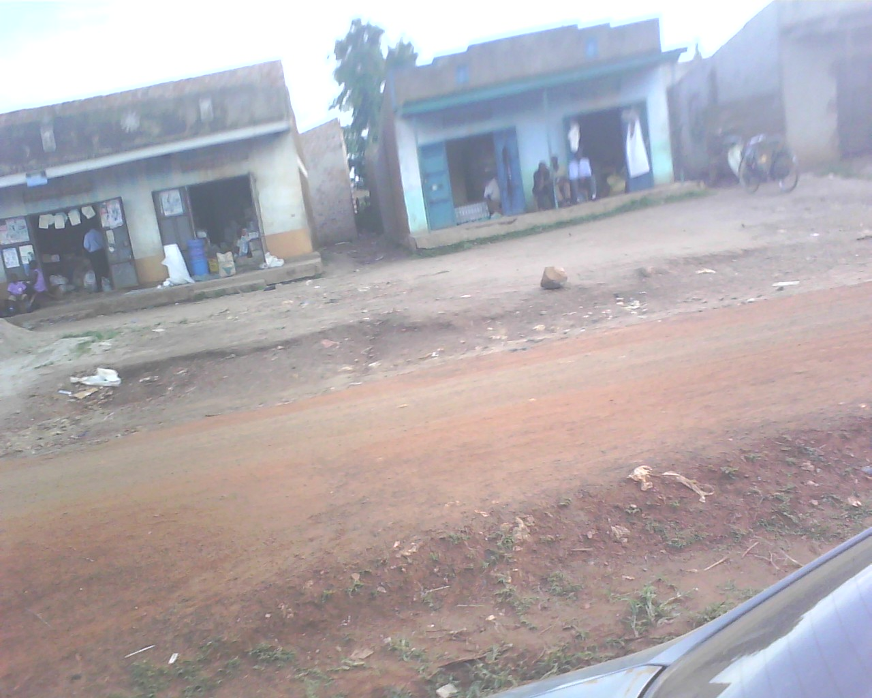
There are several pharmaceutical units with 95% being class “C”. It was observed that most of them are located in trading centers along the main access roads. It was also observed that the further ones moves away from the more active trading center like Kagadi, Kibaale, Muhororo, the fewer the drug shops.
Drug Shop in the main access road
3.3.2 Product Review

Most of the products in these shops are the class “C” drugs. Some however keep and trade in the class “B” drugs such as “Septrin” and other “strong antibiotics” illegally. There is a general outcry to put in place structures allowing class “C” shops to sell some of the vital class “B” drugs. The provision of the desired drugs at a fair price coupled with good customer care creates customer loyalty.

They serve all categories of people; business class, professionals, high and low income. But it was observed that the majority of the populations are farmers and petty traders who are rather low income earners.
Drug Shop stock with class “C” drugs

3.3.3 People’s perceptions
Kibaale has existed as an independent district for over the10 years however this period is not reflected in terms of visible growth like infrastructure. There are some deep social and cultural factors that have tended to impede fast track growth in the area.

Fortunately there are a cross section of enterprising people who once equipped with the right tools would like to venture higher and cause growth in the district.

3.3.4 Operational sustainability
For the shops to be well run there is need for capacity building and attitude change about using financial institutions. They have to improve on their savings culture, and start to appreciate loans.

3.3.5 Appropriateness of staffing
Most shops have only one nursing assistant running the shop but given the level of business they themselves confessed that they are not comfortable.


These nursing assistants need a lot of capacity building in the area of medicine they dispense and general treatment. This is because they administer first aid to most of their patience. Examples can be given in a case where some patience come up with strong malaria or a big cut while the clinic is over 50 KM away and transport is unreliable.

It is very difficult to get laboratory technicians and nurses to employ because they ask for much money which is not affordable by the drug shops owners. The nursing assistants are paid in a range of between Ug. Shs. 50,000/= Ug. Shs.100, 000/= per month while a registered nurse or laboratory technician would need a minimum of Ug. Shs.300, 000/= per month.
A Nursing Assistant
Treating a Patient

These assistants are required to make all the financial recordings in whatever format is available although they admit to not having had training in records management. However, the nursing assistants seem to be managing the shops properly though with a lot of medical and financial risks. The risks are a result of basically having obtained on-job training from their employers.

3.4 Business skill training needs
In assessing the business training needs the consultant found out that; the majority of drug shop owners were very interested in business training. A few of the drug shop owners had received some type of business management and accounting training in the past. Jecon during the assessment, examined academic education levels, business skill training needs, needs in business planning, record keeping, financial reporting, marketing and interest in future training. These findings are presented below.

Indeed there are several training gaps in these drug shops. There is need to put in place proper record keeping and financial management skills before encouraging addressing their financing needs. Otherwise, other areas of concern are:
- Governance
- Customer / Client care
- Basic finance management (basic accounting, book-keeping, stock records, costing, cash flow,)
- General business management (savings, investment and entrepreneurship)
- Other technical training gaps include:
  - Dispensing,
  - Basic treatment and
  - Diagnostic of some sickness
  - Midwifery,
  - Public health

3.4.1 Education
All the nursing assistant running the drug shops are ordinary school leavers who have undergone six month trainings in nursing assistantship. Most of them therefore lack confidence when administering the drugs. They also lack the dispensing and general business management skill. They do not appreciate records keeping and customer care.

The owners of the shops on the other hand are qualified persons to the level of certificates, Diploma and Degrees, with a few skill-based courses in their professional courses. Though qualified, they still need a lot of help in running their business. This tells us that the gaps in the sector are centered in business management on top of attitude change.

3.4.2 Business Planning

Most if not all drug shop owners set up short term goals for their businesses. Long term goals are less concrete because of the difficulty of predicting the future. Most have some type of budget for operating the drug shops although a few keep proper organized records. Business planning is therefore a necessity.

3.4.3 Records Keeping
All drug shops keep some kind of stock records and daily cash records for their inventory. Most of the drug shop owners do cash tallying on a regular basis since they are run by employees. There is need for proper and organized records keeping training.

3.4.4 Financial Reporting
There is no proper financial reporting since they do not keep any proper records.

3.4.5 Marketing
There are no written marketing plans. They sit and wait for the clients to come to their shops.

3.4.6 Future Training
All drug shop owners interviewed were interested in participating in business training. Their preferred areas of interest include Governance, Customer / Client care, Basic finance management (basic accounting, book-keeping, stock records, costing, cash flow), General business management (savings, investment and entrepreneurship) and marketing. It is important that the training be tailored to the level of the drug shop owners. Two level of training is needed; a basic introductory course would be appropriate for the sellers while fairly detailed courses should be tailored for the owners.

3.5 Finance and Financial Needs

3.5.1 Banking / Savings and Investments
Kibaale is served directly by only one commercial bank; Stanbic bank located in the main town Kibaale town. Other two banks are Centenary and dfcu Bank which serve their clients through the neighboring districts. There are a few tier 4 financial institutions (SACCOs) as shown in annexure iii, the main ones include:
- Kalibanyimukya SACCO: The biggest MFI with 3 branches and has been in operation for the last 6 years
- Hofokam MFI has 3 branches
- Kagadi Women’s Financial Services with 3 branches
- BIDECO SACCO with one branch in Muhororo
- Some ROSCAs

A good number of owners do not have business accounts for their shops basically because they seem to realize the need or it is simply not viable. For example one owner in Igayaza said,

“Our nearest bank is in Hoima and I do not trust this local bank of ours, so I keep my savings in form of stock.”

Some use the income from the drug-shops to directly finance their personal needs like school fees and other basic needs.

It was noted that although these drug-shops owners do not save directly with financial institutions they invest in heads of cattle, plots of land and commercial buildings

Tracking Financial Activity and controls
Records management and financial tracking of the drug shops is in a very absurd shape. Since most of the drug shop owners do not have proper business records, the financial trucking is low and hence high staffs turn over under the allegation of dishonesty. This has hindered most shops from growing and expanding even though they have been in existence for over 5 years. In fact some owners have deliberately refused to invest more capital into their business, for example one said,

“If it is difficult for me to know how much my business is worth and estimate what she steals at this small level, how I can risk with more capital?”

They do not keep purchases and sales records to enable them confidently plan for growth. The owners seem to know size of stock bought, the cost price and what the selling price should be.

The fact that the shop owners are all employed in government clinics /hospitals leaving them insufficient time to attend to their shops, it is the assistants who manage the shops despite lack of proper records.

3.5.2 Financing Needs and Financial Institutions
The financing needs for all the class “C” drug shops are evident and varied. BUT they need to have their records organized and governance structures put in place.

Loan size requirement ranges between Ug. Shs. 50,000/= to Ug. Shs. 2,000,000/= for the duration of between 6 months and 2 years.

JECON discussed and tried to interest the following financial institutions into opening up shops in Kibaale district in addition to the one already operating in the district: See annexure iv

To open branches
- PostBank Uganda
- Equity Bank
- Ugafode microfinance

Already operating in the district
- Kalibamunka SACCO
- Stanbic bank in Kibaale town,
- Hofokam in Kihumuro and Kagadi.
- Muhorro SIDA SACCO,

Some drug shop owners run the ROSCA and /or Merry go round scheme. This scheme has provided some financial support.

Lack of confidence in the financial institutions: - Some time back, a few SACCOs came in the area, mobilized funds and closed with peoples savings. This act has distorted the financial trust in the entire district.

Little commerce in the district: - There is little commerce in the district. Majority of the people are so engaged in the subsistence farming and shops are poorly socked

Poor savings culture: - There is poor financial savings culture. This seems to have come from the locals in the area. The drive to produce more for commercial sale is low and there is a lot of mistrust between the people. However most shops earn between Ug. Shs. 5,000/= to Ug. Shs. 200,000/= per day. This is a clear indication that they have the money to save.

Lack of borrowing culture: - Most of the shop owners have not yet borrowed money. A few who did so borrowed from their relatives. The one who borrowed from the financial institutions are the one with more than one business, or those who have been exposed to the business world. The amount ever borrowed ranges from between Ug. Shs. 500,000/= to Ug. Shs. 1,500,000/=.

However, majority of the shop owners interviewed have shown interest in accessing financial services should it be brought to them. They expressed their needs of finance ranging from Ug. Shs. 1,000,000/= to Ug. Shs. 5,000,000/= payable in between 6 months to 2 years. They also preferred to pay between Ug. Shs. 50,000/= to Ug. Shs. 100,000/= per month.

3.6 Challenges faced by the drug shop owners
The drug shop owners cited a number of Challenges they face in running a successful business, including:
- Lack of start-up capital is a barrier to entry.
- In rural areas the business can be very seasonal. People’s ability to pay for drugs is directly related to the harvest.
- Low profit. This is basically because of the kind of clients they serve and their purchasing habit (lack of capital to stock the shop or illegal style of purchases).
- Lack of availability of financing institutions and their products
- Competition from other unlicensed drug dealers
- Poor Supply of drugs

3.7 Financial institutions in Kibaale

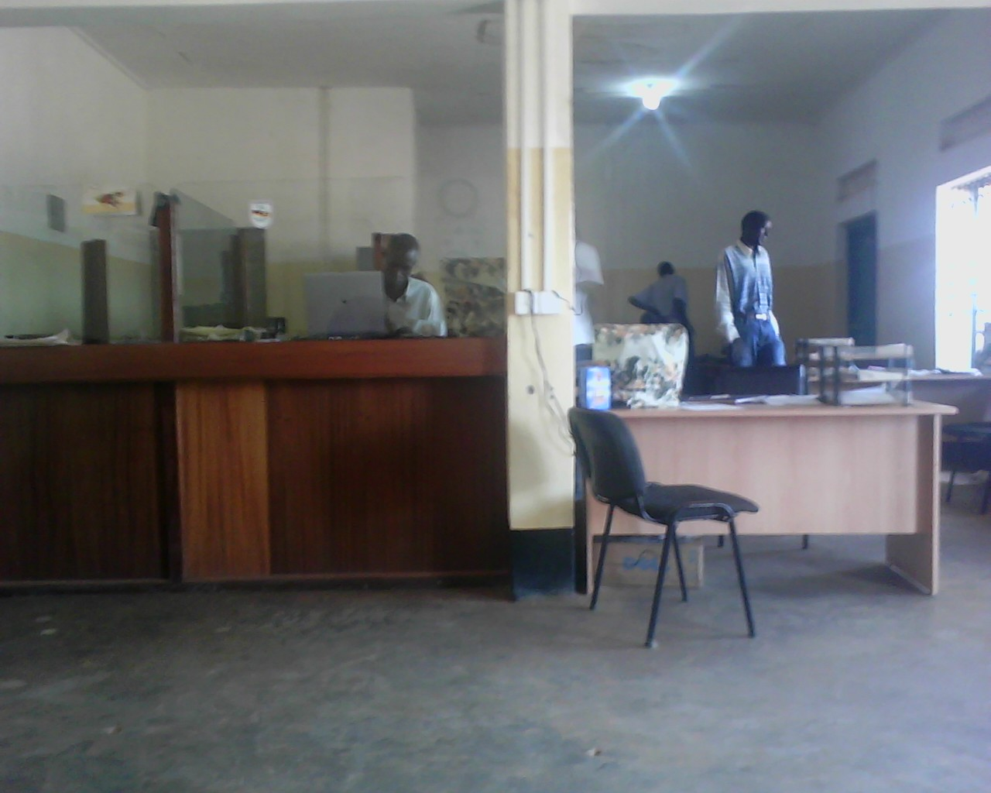
During the assessment, the JECON interviewed 7 financial institutions; kalibamunka sacco, stanbic bank in kibaale town, hofokam in kihumuro and kagadi, and muhorro sida sacco, other three banks were approached; Post bank Uganda; Equity bank and Ugafode microfinance

A few of the these financial institutions are registered with the Association of microfinance institution in Uganda (AMFIU), Uganda corporative alliance (UCA) and Uganda cooperative saving and credit union (UCUSCU) as shown in the table 3.1 below.
Inside a Financial Institution

The consultant gave a rating to each MFI and training institutions based on five criteria as shown in tables 3.1 and 3.2 below, five being the best and one being the worse.

Criteria used for rating
- Location
- Lending methodology and terms
- Availability of funding
- Number of loans active clients
- Perceived interest in working with the drug shops

The highest rating possible is 25, indicating the most appropriate partner for MSH.

Table 3.1: Summary of Ratings of financial Institutions interested in operating in Kibaale

No | Institution | Location | Methodology | Funding | Loan clients | Interest | Total | comment
 | Registered with apex bodies
1 | Kalibamunka SACCO | 4 | 5 | 3 | 4 | 5 | 21 | Good – need to be explored
2 | Stanbic bank in Kibaale town, | 1 | 2 | 5 | 2 | 5 | 15 | Not good but needs exploration
3 | Hofokam in Kihumuro and Kagadi. | 3 | 5 | 4 | 4 | 5 | 21 | Good – need to be explored
4 | Katweyombeke SACCO | 3 | 5 | 4 | 4 | 4 | 20 | Good – need to be explored
5 | Kagadi Women’s Financial Services with 3 branches | 1 | 3 | 2 | 3 | 0 | 9 | Not very convenience
6 | EMESCO | 2 | 3 | 3 | 4 | 2 | 14 | Good – need to be explored
Not registered with apex bodies
1 | Muhorro SIDA SACCO, | 1 | 5 | 3 | 4 | 5 | 18 | Good – need to be explored
2 | BIDECO SACCO with one branch in Muhororo | 1 | 3 | 2 | 2 | 2 | 10 | Not very convenience
3 | Some ROSCAs | 1 | 1 | 2 | 2 | 3 | 9 | Not very convenience
Financial institution interested in opening branches in Kibaale
1 | PostBank Uganda | 0 | 4 | 5 | 5 | 4 | 18 | Need more discussions
2 | Equity Bank | 0 | 5 | 5 | 5 | 3 | 18 | Need more discussions
3 | Ugafode microfinance | 0 | 5 | 5 | 5 | 2 | 12 | Need more discussions

4.0 Conclusion
4.1 General

Commerce
Although Kibaale is one of those districts gifted by nature, the majority of the population comprises of low income earners because they practice subsistence farming and petty trade. The main commercial centers are Kagadi and Kibaale with a few other scattered towns.

There are several drug-shops with 95% located in trading centers along the main access roads. Kibaale district is placed in better place for economic improvement.

Product Review
Most of the products in these shops are the class “C” drug shops, however, the shops keep trade in the class “B” drugs as well. There is a general outcry to put in place structures allowing class “C” shops to sell some of the vital class “B” drugs. There is also need to provide the desired drugs at a fair price coupled with good customer care to create customer loyalty.

These shops serve all categories of people; business class, professionals, high and low income. But it was observed that the majority of the population comprises of rather low income earners who cannot afford to travel long distances for Class “B” drugs. There is need to train the shop operators to administer Class “B” drugs.

People’s perceptions
Kibaale’s existence as an independent district for over the10 years with no physical reflection is an indication of deep social and cultural factors.

Fortunately there is a cross section of enterprising people who once equipped with the right tools would like to venture higher and cause growth in the district. How ever there is still need for change of perception.

Therefore, for the shops to be well run there is need for capacity building and attitude change on using financial institutions. They ought to improve their savings culture, and appreciate the need for loans to grow their businesses.

Appropriateness of staffing
The survey revealed that most shops have one nursing assistant running the shop. That is why they confessed to their discomfort in running the shops.

These nursing assistants need a lot of technical training in their area of operation (dispensing and general treatment) as well as training in business skills since they are also required to make all the financial recordings. Actually most of them admitted to not having received training in records management.

4.2 Business skill training needs
Only a few of the drug shop owners have ever received some type of business management and accounting training in the past. The majority of drug shop owners are very interested in business training.

Indeed there are several training gaps in these drug shops. There is need to put in place proper record keeping and financial management skills before encouraging addressing their financing needs. Otherwise, other areas of concern are:
- Governance
- Customer / Client care
- Basic finance management (basic accounting, book-keeping, stock records, costing, cash flow,)
- General business management (savings, investment and entrepreneurship)

Education
Most of the nursing assistant running the drug shops are ordinary school leavers who have undergone six month trainings in nursing assistantship, they lack confidence in dispensing the drugs and general business management skill. They do not appreciate records keeping and customer care.

Business Planning

Most drug shop owners have short term goals for their businesses because they have difficulty in predicting the future. Most have some type of budget for operating the drug shop although few keep proper organized records. Therefore there is need for training in business planning.

Record Keeping
Some the drug shops keep some kind of stock records and daily cash records for their inventory and do cash tallying on a regular basis since they are run by employees. These records are not up to standard. There is need for proper and organized record keeping training

Financial Reporting
JECON noted that there is no proper financial reporting since they do not keep any proper records.

Marketing
The survey revealed that the drug shops owners have no written marketing plans. They sit and wait for the clients to come to their shops. There is need to design a tailor made selling and marketing course for them.

Future Training
It was encouraging to note that all drug shop owners interviewed are interested in participating in business training. Their preferred areas of interest include Governance, Customer / Client care, Basic finance management (basic accounting, book-keeping, stock records, costing, cash flow), General business management (savings, investment and entrepreneurship) and marketing. I

JECON proposes that the trainings be tailored to the level of the drug shops; a basic introductory course would be appropriate for the sellers while fairly detailed courses should be tailored for the owners.

4.3 Finance and Financial Needs
Banking / Savings and Investments
Kibaale is served directly by only one commercial bank; Stanbic bank located in the main town Kibaale town. Other two banks are Centenary and dfcu Bank which serve their clients through the neighboring districts. There are only a few tier 4 financial institutions (SACCOs). There is need to attract more financial institutions into the district.

Tracking Financial Activity and controls
The survey revealed that records management and financial tracking of the drug shops is in a very absurd shape because most of the drug shop owners do not have proper business records. In fact some owners have deliberately refused to invest more capital into their business. It is advisable to offer them a basic accounting skill-based course.

Financing Needs and Financial Institutions
The financing needs for all the class “C” drug shops are evident and varied. They need to have their records organized and governance structures put in place.

Their loan size requirement ranges between Ug. Shs. 50,000/= to Ug. Shs. 2,000,000/= for the duration of between 6 months and 2 years. A few other financial institutions are operating in the district. However some drug shop owners run the ROSCA and or Merry go round scheme. This scheme has provided some financial support.

- Lack of confidence in the financial institutions
- Little commerce in the district
- Poor savings culture
- Lack of borrowing culture

However, majority of the shop owners interviewed have shown interest in accessing financial services should it be brought to them. They express their needs of finance ranging from Ug. Shs. 1,000,000/= to Ug. Shs. 5,000,000/= payable in between 6 months to 2 years. They also preferred to pay between Ug. Shs. 50,000/= to Ug. Shs. 100,000/= per month.

5.0 RECOMMENDATIONS
There is need for the drug shop owners to be sensitized and trained about the importance of having proper organized business if they are to prosper and grow.

5.1 Financial institutions
Because of the low level of economic activities in the district, most financial institutions are not willing to operate in the district. However, most microfinance institutions operating in the district are willing to start their operation in the area if the drug-shop owners go them. They are also willing to go out and market to the shop owners. Below are the recommended financial intuitions willing to offer financial services. A detailed list of other institutions operating in the district is in the annexure iv

To open branches
- PostBank Uganda
- Equity Bank
- Ugafode microfinance

Already operating in the district
- Kalibamunka SACCO
- Stanbic bank in Kibaale town,
- Hofokam in Kihumuro and Kagadi.
- Muhorro SIDA SACCO,

5.2 Business training skill courses
The business training needed for the shop owners and operators ought to be divided into two as follows;

Shop owners
- Governance
- Customer / Client care
- Basic finance management (basic accounting, book-keeping, stock records, costing, cash flow and budgeting)
- General business management (savings, investment and entrepreneurship)
- Business planning
- Marketing

Shop attendants
- Basic accounting (Stock record, Record Keeping ,Financial Reporting, book-keeping, costing, cash flow, and budgeting)
- Customer / Client care
- Business Planning
- Marketing

Some of the training institutions that have shown interest in delivering the services in the district are listed in the annexure iii. In fulfillment of the assignment JECON met with various business skills training firms like:
- Friends’ consult
- Demis consultant
- JECON consulting Group
- Enterprise Uganda

JECON rated the institutions as shown in table 5.1.

The highest rating possible is 25, indicating the most appropriate partner for MSH. In rating the training institutions the following were considered
- Appropriateness and quality of training materials
- Experience training
- Cost
- Perceived interest in working with the MSH and drug shop owners

Table 5.1: Training institutions and their rating

No | Institution | quality of training materials | Experience | interest | Availability | Cost | Total | comment
1 | Enterprise Uganda | 5 | 5 | 4 | 3 | 2 | 19 | Experienced and interested
2 | JECON consulting Group | 5 | 5 | 5 | 5 | 5 | 25 | Experienced and Very interested
3 | Friends consult | 5 | 5 | 4 | 4 | 4 | 22 | Experienced and interested
4 | Demis consultant | 4 | 5 | 4 | 5 | 3 | 21 | Experienced and Very interested
5 | CKm | 4 | 5 | 3 | 3 | 4 | 19 | Experienced and interested
6 | JKB | 4 | 5 | 4 | 4 | 4 | 21 | Experienced and interested
7 | SEPSPEL | 4 | 5 | 4 | 5 | 5 | 23 | Experienced and Very interested

Annexure i

List of sampled drug shops

KIBAALE DISTRICT REGISTERED DRUG SHOPS
LOCATION |  | NAME OF DRUG SHOPS |  | TOWNS
COUNTY | Sub County | Universe | Samples
BUYAGA | KAGADI TOWN COUNIL | Mugabi |  | Kagadi Town Counil
BUYAGA | KAGADI TOWN COUNIL | Ayeebale | Ayeebale | Market Street
BUYAGA | KAGADI TOWN COUNIL | SA & EM | SA & EM | Market Street
BUYAGA | KAGADI TOWN COUNIL | Murungi | Murungi | Market Street
BUYAGA | KAGADI TOWN COUNIL | The Lord is my shepherd | The Lord is my shepherd | Buyaga Road
BUYAGA | KAGADI TOWN COUNIL | St Luke |  | Market Street
BUYAGA | KAGADI TOWN COUNIL | Mugabi D/S |  | Ruteete
BUYAGA | KAGADI TOWN COUNIL | Ashermans
BUYAGA | MUHORRO | St Jude |  | Muhorro Trading Centre
BUYAGA | MUHORRO | Byomulembe | Byomulembe | Muhorro Trading Centre
BUYAGA | MUHORRO | Muhorro peoples Care |  | Muhorro Trading Centre
BUYAGA | MUHORRO | Hati muhumule |  | Muhorro Trading Centre
BUYAGA | MUHORRO | BAATA | BAATA | Muhorro Trading Centre
BUYAGA | MUHORRO | Kabanza | Kabanza | Muhorro Trading Centre
BUYAGA | MUHORRO | Murungi |  | Muhorro Trading Centre
BUYAGA | MUHORRO | Fiath |  | Nyakasozi
BUYAGA | MUHORRO | Nyanseke rural D/S |  | Nyanseke
BUYAGA | BWIKARA | Medi Care D/S |  | Kamusegu
BUYAGA | BWIKARA | Paradise D/S |  | Kamusegu
BUYAGA | KIRYANGA | God Cases |  | Kiryanjaji
BUYAGA | KIRYANGA | St Jude |  | Kiryanjaji
BUYAGA | KIRYANGA | Murungi |  | Pacwaa
BUYAGA | KIRYANGA | Mukama Murungi |  | Bugwara
BUYAGA | MPEEFU | Kasojo D/S |  | Kasojo
BUYAGA | MPEEFU | Kyaterekera |  | Kyaterekera
BUYAGA | MPEEFU | Asirigya | Asirigya | Kyaterekera
BUYAGA | MPEEFU | Charity | Charity | Kyaterekera
BUYAGA | MPEEFU | Kyaterekera people’s |  | Kyaterekera
BUYAGA | MPEEFU | God Heals |  | Kyaterekera
BUYAGA | MPEEFU | God’s Mercy |  | Kasojo
BUYAGA | MPEEFU | Kobomu |  | Kobushera
BUYAGA | MPEEFU | St Martin |  | Kyaterekera
BUYAGA | MPEEFU | Tukundane |  | Mpeefu
BUYAGA | RUGASHALI | Burora | Burora | Burora
BUYAGA | RUGASHALI | Mukama Murungi | Mukama Murungi | Rugashali
BUYAGA | RUGASHALI | Glory D/S | Glory D/S | Burora
BUYAGA | RUGASHALI | Byava | Byava | Rugashali
BUYAGA | MABAALE | Akwehairwa |  | Mabaale
BUYAGA | MABAALE | Friends |  | Mabaale
BUYAGA | MABAALE | Nantamba |  | Mabaale
BUYAGA | MABAALE | Silvers medicines |  | Mabaale
BUGAGAZI | NALWEYO | St Matha | St Matha
BUGAGAZI | NALWEYO | Beth Said
BUGAGAZI | NALWEYO | Good Samaritan
BUGAGAZI | NALWEYO | Kasagama
BUGAGAZI | NALWEYO | St Nicholas
BUGAGAZI | KISITA | Universal |  | Kisita T/C
BUGAGAZI | KISITA | Chemo |  | Kisita T/C
BUGAGAZI | KISITA | Care | Care | Kisita T/C
BUGAGAZI | KISITA | St Albert | St Albert | Kyagota T/C
BUGAGAZI | KISITA | Twesige |  | Buhonda T/C
BUGAGAZI | KONKO | Good is able |  | Mpasana
BUGAGAZI | KONKO | Jamppade |  | Kabuubwa T/C
BUGAGAZI | BWANWSA | Kayi | Kayi | Kakumiro
BUGAGAZI | BWANWSA | Kakumiro | Kakumiro | Kakumiro
BUGAGAZI | BWANWSA | Akwatampola | Akwatampola | Kakumiro
BUGAGAZI | BWANWSA | Green valley | Green valley | Kakumiro
BUGAGAZI | BWANWSA | Ebenezer | Ebenezer | Kihumuro
BUGAGAZI | KAKINDO | Mwesigwa | Mwesigwa | Igayazza
BUGAGAZI | KAKINDO | Multi Care |  | Igayazza
BUGAGAZI | KAKINDO | Musimenta | Musimenta | Igayazza
BUGAGAZI | KAKINDO | St Charles |  | Kikwaya
BUGAGAZI | KAKINDO | Johnson |  | Igayazza
BUGAGAZI | KAKINDO | MAMO |  | Kikwaya
BUGAGAZI | KAKINDO | Immys | Immys | Lussolera
BUGAGAZI | KAKINDO | St Juliet |  | Igayazza
BUGAGAZI | KAKINDO | Kagame |  | Kakindo
BUGAGAZI | KAKINDO | Sanyu D/S | Sanyu D/S | Igayazza
BUGAGAZI | KASAMBYA
BUGAGAZI | KASAMBYA | Mother Care |  | Kisengwa
BUGAGAZI | KASAMBYA | Nguse D/S |  | Kasambya
BUGAGAZI | KASAMBYA | Katonko |  | Kasambya
BUGAGAZI | KASAMBYA | BMA |  | Nyansimbi
BUGAGAZI | KASAMBYA | Bakurungo |  | Kiboijane
BUGAGAZI | KASAMBYA | Birembo |  | Birembo
BUGAGAZI | BWAMIRAMIRA | Hp Modern | Hp Modern | Karuguuza
BUYANJA
BUYANJA | BWAMIRAMIRA | Ahumuza | Ahumuza | Karuguuza
BUYANJA | BWAMIRAMIRA | St Peters |  | Karuguuza
BUYANJA | BWAMIRAMIRA | God’s Will | God’s Will | Karuguuza
BUYANJA | BWAMIRAMIRA | St Berna | St Berna | Karuguuza
BUYANJA | BWAMIRAMIRA | Mirabe |  | Bukonda
BUYANJA | BWAMIRAMIRA | St Theresa | St Theresa | Bukonda
BUYANJA | BWAMIRAMIRA | God Cares |  | Kabasekende
BUYANJA | BWAMIRAMIRA | Mpora Mpora |  | Ngangi
BUYANJA | BWAMIRAMIRA | Mirembe |  | Kibali
BUYANJA | BWAMIRAMIRA | St Anna |  | Ngangi
BUYANJA | MUGARAMA | Burunzi D/S
BUYANJA | MUGARAMA | Jesus is Enough |  | Nyamanda
BUYANJA | MUGARAMA | Mugarama |  | Mugarama
BUYANJA | MUGARAMA | Turibamu |  | Nyamarunda
BUYANJA | MUGARAMA | Mirembe D/S | Mirembe D/S
BUYANJA | MATALE | Divine |  | Busesa
BUYANJA | MATALE | Owomugisa |  | Busesa
3 | 16 | 93 | 31

Annexure ii

List of financial institutions

EMESO Development Foundation
Tier 4
Category C
Legal Status Company Limited by Guarantee
Contact Person Emely Kugonza (Mr)
Address P.O. Box 32 Karuguuza
Karuguuza-Kibaale Town Council
District Kibaale
Telephone 0772513279
Email emesco@iwayafrica.com

Business Information
Outstanding Loan Portfolio 539,135,747
No of active Borrowers 1,386
Percentage of female borrowers 39%
Total number of clients 3,296
Percentage of female clients 45%
Interest rate calculation Flat rate
Average 1 st loan 400,000
Current Average Loan size 388,986.8
Minimum loan size 50,000
Maximum loan size 3,000,000
Maximum loan period 1 month
Max loan period 12 months

Products offered
- Individual loans
- Group loans
- Salary loans
- Asset loans

Number of Branches
Branch name Town District
Kagadi Kagadi Town Council Kibaale
Muhorro Muhorro Town Board Kibaale
Kisiita Kisiita Town Board Kibaale

Kagadi Women’s Financial Series
Tier 4
Category D
Legal Status Company Limited by Shares
Contact Person Gorreti Wanyala
Address P.O. Box 33 Kagadi
Kagadi Town Council
Isunga Rd
District Kibaale
Telephone 0392829153, 0772365498, 0772538703
Email wanyanag@yahoo.com

Business Information
Outstanding Loan Portfolio 328,993,500
Total compulsory savings 76,005,000
Total No of active savers 857
Percentage of female savers 70%
No of active borrowers 624
Percentage of female borrowers 65%
Total number of clients 980
Percentage of female clients 80%
Interest rate calculation Flat rate
Average 1 st loan 200,000
Current Average Loan size 1000,000
Minimum loan size 100,000
Maximum loan size 10,000,000
Maximum loan period 3 months
Max loan period 12 months

Products offered
- Credit
- Savings
- Counselling
- Training members

Kalibayimukya SACCO
Tier 4
Category C
Legal Status SACCO
Contact Person Francis Kasumba
Address P.O. Box 100 Hoima
Kakindo Town Council
Bugangazi County
District Kibaale
Telephone 0782961553, 0782448085

Business Information
Outstanding Loan Portfolio 355,904,666
Total voluntary saving 461,843,289
Total N o of active savers 3,462
Percentage of female savers 19%
No of active borrowers 829
Percentage of female borrowers 17%
Total number of clients 4,034
Percentage of female clients 17%
Interest rate calculation Flat rate
Average 1 st loan 400,000
Current Average Loan size 800,000
Minimum loan size 50,000
Maximum loan size 4,000,000
Minimum loan period 1 day
Max loan period 9 months

Products offered
- Commercial loans
- Agricultural loans
- Housing loans
- Solar Energy loans
- Social Loans
- Educational loans
- Quick one day loans
- Group loans

Number of Branches 3
Branch name Town District
Kakindo Kakindo Town Council Kibaale
Kagadi Kagadi Town Council Kibaale
Kakumiro Kakumiro Town Council Kibaale

Katweyombeke Savings & Credit Co-op Ltd
Tier 4
Category D
Legal Status SACCO
Contact Person Lamuel Byamugisha
Address P.O. Box 24 Hoima
Kisiita S C Bugangazi
District Kibaale
Telephone 0465442943, 0772416725

Business Information
Outstanding Loan Portfolio 116,398,228
Total voluntary saving 113,203,227
Total N o of active savers 961
Percentage of female savers 16.8 %
No of active borrowers 308
Percentage of female borrowers 12.3%
Total number of clients 1,232
Percentage of female clients 13.2%
Interest rate calculation Flat rate
Average 1 st loan 428,675
Current Average Loan size 555,025
Minimum loan size 100,000
Maximum loan size 5,000,000
Minimum loan period 1 month
Max loan period 12 months

Products offered
- Business loans
- Quick Emergency loans
- Agricultural loans
- School fees loans
- Oasis Loans

Number of Branches 1
Branch name Town District
Mwitanzinge Mwitanzinge Town Council Kibaale

Annexure iii

List of training institutions

CKM Consultants Ltd.
P.O. Box 4246, Kampala
Plot 2, Old Port Bell Road, Kampala
Tel: 0414-343380
Kampala

Contact Person: Christopher Musoke

Development and Microfinance Services (DEMIS) Consultants Limited
P.O. Box 1551, Kampala
Plot 960/961, Entebbe Road, Millenium Chambers, NajjanaKumbi
Tel: 0414-235773
Contact person: Anthony Ndora

Enterprise Uganda
P.O. Box 24581, Kampala – Uganda
Plot 38, Lumumba Avenue Nakasero
Tel: 0414-251810
Kampala

Contact person: Charles Ocici
Friends Consult Ltd
P.O. Box 24366, Kampala
Alandro House,
Plot 2052 / 53, Kalina, Kisugu
Tel: 0414-349381
Kampala
Contact person: Andrew Obara

JECON Consulting Group Ltd
P.O. Box 32260, Kampala
Plot 66 Kenneth Dale Drive – Kamwokya
Tel: 0414 – 378514
Kampala
Contact person: Olanya Jimmy Olenge

JKB Finance and Management Consultants
P.O. Box 9524
Kampala Uganda
KATI HOUSE Floor 1 Room 2
Kisozi Close, 2 Kyagwe Road
Tel:0414-234467
Kampala
Contact Person: John K. Beijuka

South Eastern Private Sector Promotion Enterprises Ltd (SEPSPEL)
P.O. Box 62, Busia
Plot 17, Majanji Road
Tel: 0454443479
Busia

Contact Person: Joseph Byabazaire

Annexure iv

Questionnaire sample

Field Assessment Questionnaire for MSH in Kibaale

Institutional performance plans,
- Do you have a strategic business plan?
- For how many years is it?
- How do you break up your business plan in to action plans?
- Who did it for you?
- How do you monitor your performance?
- How do you rate your performance against the targets set?
- How do you rate your performance against the competitors?

Factors that impede or hinder the progress of YOUR BUSINESS
- What challenges do you face in the following areas:
- Human resources
- Credit
- Recruitment,
- Training,
- Marketing
- Competition

Operational and financial review - ability to achieve financial sustainability soon
- Growth strategy and competitive advantage.
- Asses the appropriateness of the drugs to satisfy patients needs.
- Best practice management in relation to policy, strategy, leadership partnerships, resources and processes.

Product review
- Which is/are the most preferred drugs by your patients?
- Why do you think your patients prefer these drugs (s)?
- Have patients ask for drugs that you do not have?
- If yes which one?
- What benefit do you think YOUR DRUG SHOP gives to patients?

Delivery Method (s)

How many drugs do you have?

Types / class of drugs

What is your target group?
- Business
- Employees
- Students
- High income
- Low income
- How do you get patients?

Appropriateness of staffing
- What are the qualifications of your staffs
- Teamwork / mutual support and cooperation
- Staff as self starters / high initiative
- Accountability for results and actions
- Open to change
- Innovation encouraged / creativity welcomed Feedback and coaching
- Good performance recognized and rewarded Core values and ethics known, shared, emphasized People feel appreciated and valued
- Trust I openness between people
- Positive / optimistic / forgiving
- Do your staffs have appropriate skills and experience for their respective positions?
- Are the roles, segregation of duties and linkages clearly
- Do you have well defined Recruitment policies and are they appropriate and practiced?
- Staff training and development plan
- How often do you carry out staff appraisal / performance (measurement system)
- What is your salary structure like
- How comparable is it
- Which skills training do you need to make Your business more competitive

Patients
- Do you train your patients on your drug shop?
- Do you train your patients on your drug shop’s drugs?
- How often do you mingle with your patients after work?
- How do you register your patients’ dissatisfaction / satisfaction?
- What language do you speak with your patients?
- How is your communication within the shop?
- Do you receive recommendation from the patients?
- How are patients’ disputes solved?
- How do you solve you internal staff dispute?

Tracking Financial Activity
- All income transactions supported by documents
- All payment transactions supported by documents
- All non cash transactions supported by documents
- All debtors tracked
- All liabilities and commitments tracked
- Official docs bear pre-printed serial numbers
- Appropriate books of prime entry maintained
- Chart of accounts appropriate
- Books of prime entry summarized using double entry
- Accounting policies appropriate
- Computers used to maximum effect

Controls

Income and receipts
- Invoices raised as appropriate
- Receipts are issued
- Receipt books controlled
- Completeness of receipts recording checked
- Matching of receipts and invoices
- Intact banking of receipts
- Debtors analyzed and followed up
- Commitments, payments and accountability
- Expenditure is approved before it is made
- Authorization procedures appropriate
- The budget is used for pre-spending budgetary control
- Payments only made on invoices, not statements
- Unaccounted for working advances are tracked
- Unpaid invoices recorded as received
- Payment vouchers raised for all payments
- Accountabilities checked

Cash and bank
- Petty cash impress system is operated
- Cash counts performed and documented
- No unnecessary bank accounts
- Appropriate signatories
- Cheque book held by someone who is not a signatory
- No signing of blank cheques
- Bank reconciliations performed monthly

List your present job

When did you start business

What does your present job entail?

Who do you report to?

Are you well conversant with your current job?

What area(s) do you still need more training?

How challenging is your current job?

Do you achieve your targets?

If not, what do you suggest should be done to help you meet your targets

Education

What is your highest level of academic qualification? (List the institution and year of studies)

Have you studied any professional course? List them

Have you attended skill based courses? List them:

Are you currently in school?

Are all the courses done relevant to your present job?

What other areas of profession do you wish to peruse and why?

Way forward and future endeavor.

What are your future plans?

How do you plan to improve on your services

Will you want to be trained?

If yes, in what area

Financial needs

How did you start this business?

How long have you been in the business

Do you meet the needs of your patients?

If not, what do you think is the problems?

How much do you sell / make in a day

Where do you get financial support?

Business skills training needs

Do you keep receipts of sales?/ how do you record your sales

If yes, are you satisfied with the books of accounts?

If no, how do you know your sales?

What training would you want for your business?

Annexure v

Terms of reference

DEVELOPMENT OF RECOMMENDATIONS FOR BUSINESS SKILLS TRAINING OF DRUG SELLERS AND OWNERS AND BUSINESS FINANCING AS RELATED TO IMPLEMENATION OF THE UGANDAN ADDO INITIATIVE

- Objective
The objective of these terms of reference (TOR) is to outline tasks/scope of work to be undertaken by a short-term consultancy (STC) to assist in the development of recommendations for business skills training and business financing as related to implementation of the Ugandan Accredited Drug Dispensing Outlets (ADDO) initiative.

- Background
Management Sciences for Health (MSH) in collaboration with the National Drug Authority (NDA) and the Pharmaceutical Society of Uganda (PSU) wants to develop a sustainable accredited drug dispensing outlet initiative for Uganda that will be piloted and evaluated in Kibale district.

The idea of establishing ADDO shops builds on MSH’s Strategies for Enhancing Access to Medicines (SEAM) Program, which, in collaboration with the government of Tanzania, launched the country’s successful accredited drug dispensing outlet (ADDO) program. Similar to the situation in Tanzania, drug sellers in Uganda’s Class C drug shops lack adequate business and dispensing skills, often do not have the financial resources to meet requirements of accreditation, and have limited knowledge in managing common illnesses in the community.

Although the Class C shops operate in an unregulated fashion, they are a necessary service to the majority of the population in the rural areas where there are no pharmacies. Even though these drug outlets are restricted to the sale of Class C medicines, assessments carried out in the districts of Kibale and Mpigi revealed that they sell medicines beyond their legally-mandated scope in order to meet the genuine and basic needs of the rural population they serve.

The ADDO program therefore intends to upgrade these shops through an accreditation process of both the premises and the service providers. This will allow them to legally stock and sell a limited number of essential prescription medicines to serve the population.

In order to be profitable and sustainable in the long term without continuing donor support or subsidies, shop owners and dispensers must have appropriate business skills. They will also need to have access to financing that will allow them to meet requirements of an accredited shop and the increased level of medicines inventory that will have to be stocked and maintained.

- Description of work to be performed
The consultant shall:

  - Conduct assessments to determine financing needs and business skills training needs of Class C drug shop owners and drug sellers in Uganda.

  - Identify potential financing options for ADDO owners in order to upgrade their shop premises, increase inventory, and meet other requirements of being an accredited drug dispensing outlet. Among other options, micro financing and the role of SACCOs should be explored.

  - Identify potential partners in the microfinance industry along with key micro financing implementation issues.

  - Identify potential partners in the business skills training industry and key implementation issues.

  - Make recommendations regarding options for providing financing and business skills training to ADDO owners and drug sellers.

  - Perform any other related assignment as may from time to time be called upon and agreed between the consultant and MSH.

- Schedule
  - Assessments to determine financing needs and business skills training needs of Class C drug shop owners and drug sellers in Uganda (3.1) should be completed within 10 working days of signing of contract.
  - Identification of financing options (3.2), potential financing partners (3.3), and potential business skills training partners (3.4) should be completed within 15 working days of signing of contract.
  - Final recommendations for options for providing financing and business skills training to ADDO owners and drug sellers (3.5) should be completed within 20 days of signing of contract.

- Deliverables
  - Needs assessment report completed within 10 days of signing of contract.
  - A list of potential financing and business skills training partners, along with a description of potential partner capabilities, completed within 15 days of signing of contract.
  - Final recommendations completed within 20 days of signing of contract.

- Duration of assignment
The duration of this assignment is expected to be not more than 20 working days from the date that a contract is signed for this work. The consultant shall provide a financial proposal for the work.

