MANAGEMENT SCIENCES FOR HEALTH
PHARMACEUTICALS AND HEALTH TECHNOLOGIES GROUP (PHT)
LaunchDSI Project

NIGERIAN DELEGATION [PHARMACISTS COUNCIL OF NIGERIA (PCN) AND DEPARTMENT OF FOOD & DRUGS SERVICE, FEDERAL MINISTRY OF HEALTH] STUDY TOUR TO TANZANIA
- BACKGROUND
Management Sciences for Health (MSH) is funded by the Bill & Melinda Gates Foundation to implement a four year program (LaunchDSI) to facilitate the development, implementation and scale up of accredited drug seller initiatives (ADSI's) to increase access to pharmaceutical products and services in Africa through private-public partnerships. LaunchDSI has established a technical resource center in Tanzania which provides technical assistance and small start-up grants to assist interested African countries to adopt and if possible replicate the Accredited Drug Dispensing Outlets (ADDO) model. A number of countries have shown interest and these include Uganda, Liberia, Zambia, Burundi, Sierra-Leone, Mali, Democratic Republic of Congo (DRC) and Nigeria. PCN has expressed its interest in accessing technical support and a small start-up grant to enable it to initiate and implement a drug seller initiative, with a focus on improving the capacity of its workforce and stakeholder involvement at all levels especially community participation, thereby strengthening its regulatory functions, viz-a-viz availability at all times of medicines that are affordable, safe and of good quality. It is with this background that LaunchDSI (after consultations with PCN) felt that a study visit to Tanzania would be crucial in facilitating the development and implementation of an accredited drug seller initiative (ADSI) that suits Nigeria.

- TRIP’S OBJECTIVES
The main goal of this study visit was to learn from the Tanzanian Ministry of Health and its relevant Regulatory Authorities (Tanzania Food and Drugs Authority and the Pharmacy Council) on their experiences in developing and implementing ADDOs. The specific objectives of this study tour were;
- Meet with the Permanent Secretary and the Chief Pharmacist, (MOHCDGEC ) for an overview of pharmaceutical sector in Tanzania.
- Familiarize with Tanzania pharmaceutical sector regulatory framework (regulation of food, medicines, cosmetics and medical devices and regulation of pharmacy practice, premises and personnel).
- Learn the Tanzania ADDO program implementation experiences (Pharmacy Council and MSH).
- Conduct field visits to nearby regions (Dar es Salaam, Pwani and Morogoro) to learn operation of pharmacies and ADDOs.

- OVERALL DESCRIPTION OF THE VISIT

Day 1 (2nd May 2016)-Courtesy Call at the MOHCDGEC and a visit to MSH offices

The team paid a Courtesy call at the Ministry of Health, and met high level officials including the Acting Permanent Secretary (Dr. Mohamed A. Mohamed ), the Chief Pharmacist (Henry Irunde) and the Registrar, Pharmacy Council (Elizabeth Shekhalaghe) at the Ministry of Health, Community Development, Gender, Elderly, and Children. They listened to a presentation from the Chief Pharmacist on the pharmaceutical sector and the regulatory environment in Tanzania. The Nigerian team also presented on the Nigerian Pharmaceutical Sector, PCN, and the Patent & Proprietary Medicine Vendors (PPMVs) in Nigeria. Discussions on and around the public and private sector supply chain and the similarities & differences between the Nigerian & Tanzanian pharmaceutical sectors took place after presentations. They were taken to visit a nearby Community Pharmacy (which they confessed was not very different from a Nigerian Community Pharmacy).

The rest of the day was spent at MSH offices where they were introduced to the MSH Tanzania team before listening to Dr. Kimatta’s presentation on the overview of MSH Tanzania. They also had the opportunity to view the ADDO video, which gave them an idea of what the ADDO program is all about before PC’s presentations (which were scheduled for the next day). A welcome dinner at the Serena Hotel, hosted by MSH Tanzania summed up the first day.

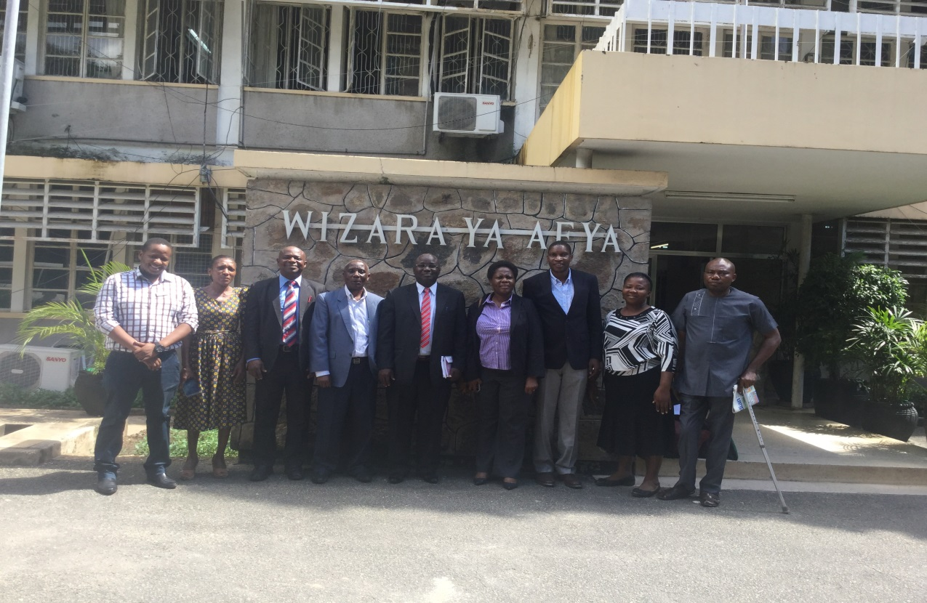
Nigerian delegation with PC & MSH staff at the MOHCDGEC

Day 2 (3rd May 2016)-A visit to TFDA, PC and travel to Kibaha & Morogoro)

Accompanied by the MSH Tanzanian team, the Nigerian delegation visited the Tanzania Food and Drugs Authority and Pharmacy Council, where they met the Acting Director General of the TFDA (William Wigenge) who is also the TFDA Director of Food Safety, and the Registrar of the Pharmacy Council (Elizabeth Shekhalaghe), together with the rest of the TFDA & PC staff. They listened to presentations on the overview of TFDA, and one about drug registration and importation in Tanzania. They also had presentations from the Pharmacy Council on an overview of PC, and the ADDO Program in Tanzania. Lots of discussions focused on the comparison between the PPMVs and ADDOs, regulatory functions and scope in the two countries, composition of inspectors and law enforcers within PCN, and lessons learned & challenges faced in implementing ADDOs.

The team left for Kibaha and Morogoro on the same day (accompanied by Eliphace Mkumbo-MSH, Zainabu Nyamungumi-PC and Geofrey Mjema -Kibaha District Pharmacist). They had an opportunity to visit two peri-urban ADDOs in Mlandizi (Kibaha District), and they appreciated the need to have premise standards, drug dispensing documenting tools (drug registers), and the mobile reporting system. They also saw PCs accreditation evidence (registration of premises and personnel certificates & licenses).
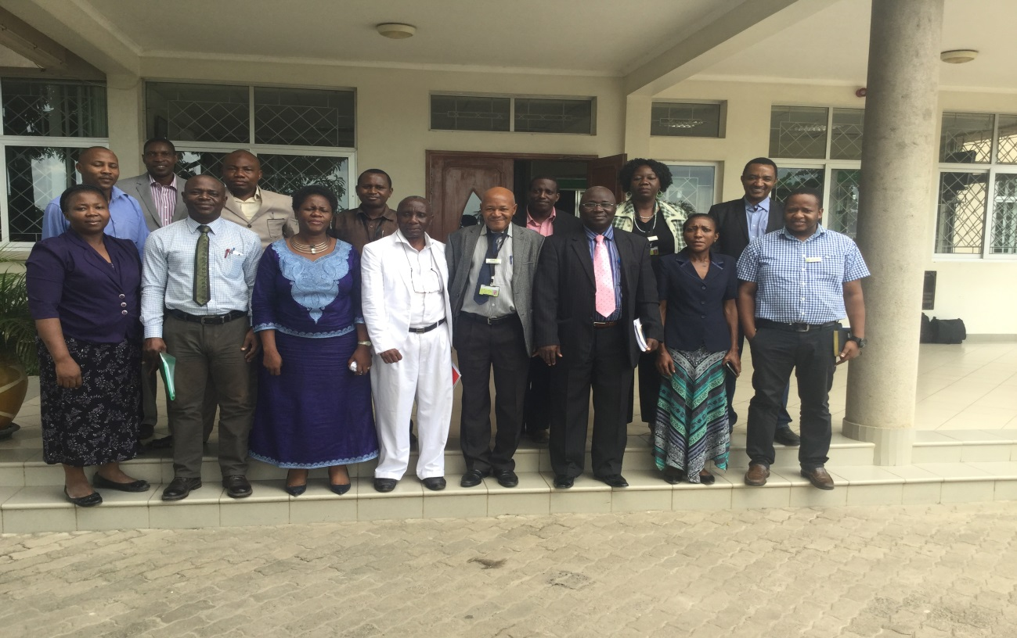
Nigerian delegation after the meeting at TFDA/PC

Day 3 and 4 (4th -5th May 2016)-Visit ADDOs in Morogoro Rural

The team paid a Courtesy call at the Morogoro Rural District Council, and met the District Medical Officer, Dr. Mahizo before embarking on a tour to see two rural based ADDOs (in Ngerengere) and one peri-urban ADDO (in Mikese). They appreciated the difference between rural and peri-urban ADDOs in terms of stocking and infrastructure, but with all of them adhering to premise standards. They also saw an ADDO that has been registered to provide medicines & supplies to National Health Insurance Fund (NHIF) card holders. They were generally happy to see how premises and personnel standards are maintained regardless of the location, presence of ADDO signposts at each shop and the good relationship that exists between the local leaderships and regulators.
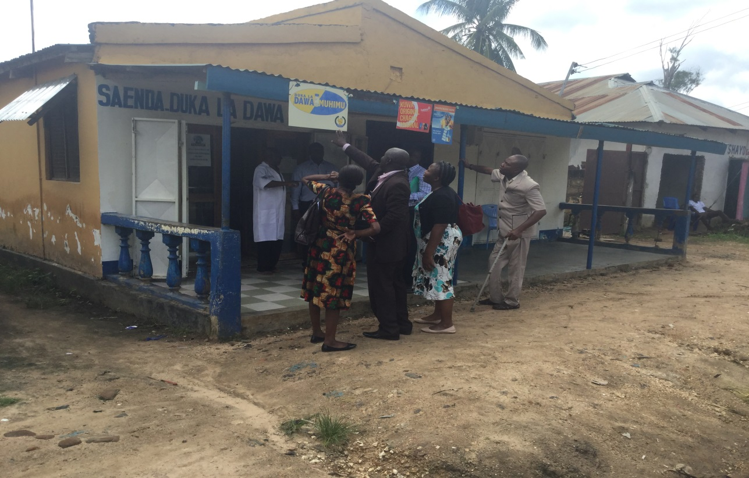
Delegates looking at an ADDO signpost (Saenda DLDM in Ngerengere-Morogoro Rural)

Day 5 (6th May 2016)-Debriefing at the MOHCDGEC and lessons learned

The delegation met the MOHCDGEC Chief Pharmacist and the rest of the Pharmaceutical Services Unit (PSU) staff. Also, in attendance were the Registrar of the Pharmacy Council and some of her staff, and representatives from MSH. The Nigerian delegation commended Tanzania MOHCDGEC’s efforts in improving access to medicines in a regulated manner. They reported to have learned the following;
- The need for setting standards and the importance of accreditation and licensing for both premises and practitioners. They were able to see certificates and licenses (displayed) of practitioners and premises
- Documentation tools for monitoring, evaluation and reporting--Drug registers which are the major source of data from the ADDOs and Visitor’s registers
- The importance of the database & sms mobile system for recording, reporting, making enquiries, and making payments
- Use of the Facility Identification Number (FIN) and Personnel Identification Number (PIN) for premises and personnel identification respectively
- A commendable and stable administrative structure down to the village & hamlet level which in a way supports the ADDO program
- Presence of a referral component in the ADDO model
- Use of ADDOs as a platform for other public health interventions such as family planning, HIV/AIDS, and malaria
However, delegates recommended the following in order to further improve the ADDOs;
- Further regulation of access to prescription medicines. They had witnessed one ADDO dispenser issuing antibiotics without a prescription
- PC not to only rely on training and supervision---but also adequate regulation & law enforcement in implementing the program
- Increasing the number of primary and simple health management manuals at the ADDO level

- NEXT STEPS &THE WAY FORWARD
Based on lessons learned from the ADDO model, the Nigerian delegation and the LaunchDSI team agreed on the following tentative next steps which will be finalized after further discussions within Nigeria and with LaunchDSI.

S/N | Activity | Approximate Timeline
1 | Report writing on study tour and presentation to PCN Registrar | May 2016
2 | Desk review and situation analysis via survey pilot  [Identify gaps viz a viz knowledge of ADDO/ need for new cadre] | May – June 2016
3 | High level Federal Ministry of Health (FMOH) committee meeting which was already thinking in this direction | July 2016
4 | Sensitization of key stakeholders  - PCN  - PCN committee  - FMOH  - PSN  - ACPN  - NAPHA  - MSH  - Committee members on re-positioning pharmacy education and practice in Nigeria  - Others | August 2016
5 | Third meeting of the Committee | August 2016 (immediately after item 4)
6 | Wider stakeholder engagement- with sign off on statement of commitment  - PCN  - PSN and its technical arms  - Funder/donor  - Implementing Partners  - Press and print media  - Health care providers  - Associations | September 2016
7 | Technical support from Tanzania team  Develop tools and pilot plan ; Select and initiate pilot in one or two states  Setting indicators and guidelines /IEC development | Oct-Dec. 2016.
8 | Engagement/ sensitization of stakeholders at state level
9 | GIS mapping of facilities
10 | Dissemination of report and way forward planning
11 | Roll out

Names of delegates
S/N | NAME | ORGANIZATION
1 | Pharm. Ibrahim Babasheu Ahmed | Pharmacists Council of Nigeria (PCN)
2 | Pharm. Ilupeju Thomas Omotayo | Pharmacists Council of Nigeria (PCN)
3 | Pharm. Ibrahim Mohamed | Food & Drugs Services Department, Federal Ministry of Health
4 | Pharm. Maria Adu Ochigbo | MSH-Nigeria

Ministry of Health, Community Development, Gender, Elderly and Children
All ADDOs are required to have a minimum of two rooms, and at least one window in each room
Committee on re-positioning pharmacy education and practice in Nigeria’ inclusion of DFDS/FMOH

