A report on the launchDSI stakeholders meeting
Consultant:
Maija Aziz
Telephone: +256 754 875 795
E-mail: azmaija@gmail.com
ADS Coordinator:
Lubowa Nasser

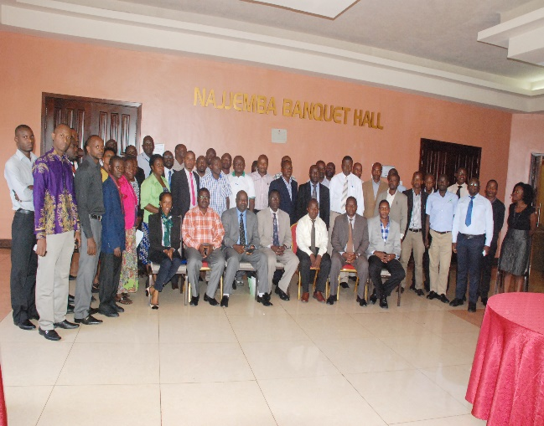

Submitted to;
LaunchDSI MSH & National Drug Authority,

Background
The National Drug Authority (NDA) in Collaboration with Management Sciences for Health (MSH) piloted the Accredited Drug Shop (ADS) initiative aimed at increasing access to essential medicines in rural underserved areas of Uganda through involvement of the private sector drug shops. Stakeholders identified the National Drug Authority as the lead implementing partner with the Ministry of Health providing overall policy guidance and MSH providing the technical support. Nine districts were implemented through 2015. With funding from the Bill and Melinda Gates Foundation, through MSH under the Launch Drug Sellers Initiative (LaunchDSI), NDA will scale up ADS to five additional districts and is now making efforts geared towards sustaining the program post LaunchDSI funding.
Key implementation activities to transform existing class C drug shops into Accredited Drug Shops include the training and certification of drug shop attendants, business training for shop owners, local monitoring, and supportive supervision.

2: Workshop Objectives

- Broad Objective

To discuss on the implementation of the MSH-LaunchDSI-supported scaling up of Accredited Drug Shops and the program’s sustainability in Uganda

- Specific Objectives

- Share on the contribution of the Accredited Drug Shops to Public Health Interventions so far
- Discuss and agree on the best possible ways of scaling up the ADS program to the rest of the country
- Discuss on partnerships, collaborations, and how best can different partner’s activities conducted through drug shops be harmonised to improve services and leverage resources
- Discuss the most appropriate strategy for the maintenance and sustainability of the ADS initiative post LaunchDSI.

3: Methodology
The workshop was on September 22, 2016 at Royal Suites hotel, Bugolobi. The following methods were used:
- Power point presentations
- Questions, answers, explanations and discussions after each presentation
- Recommendations from the stakeholders

4: Workshop Participants
- Officials from the Ministry of Health including Reproductive Health, Family Planning and Child Health division
- NGOs implementing programs for donors and/or in the drug shops such as UHMG, Malaria Consortium, FHI 360, UHSC,CHAI, UHF ,HEPS, etc.
- Training institutions conducting ADS training –FINS
- Local government representatives from ADS implementing districts
- NDA regional inspectors
- Representatives from UNFPA, WHO

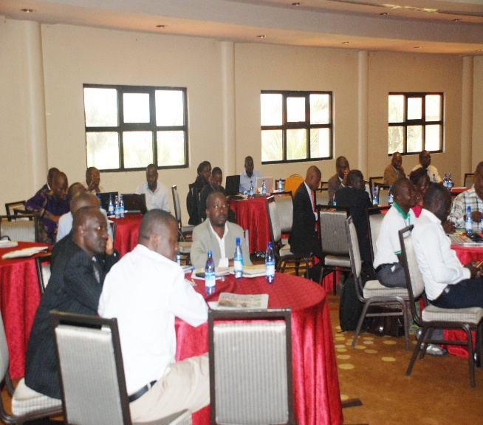
5: Accomplishments from the workshops

- Participants especially the Ministry of Health officials were able to get a better understanding of the ADS contribution to public health especially the vertical programs. However, NDA was tasked to engage and keep them abreast of the progress being made. It was noted that the ministry was not fully in touch with the NDA programs
- There was consensus generated from all the stakeholders on the need to harmonise the interventions happening in the drug shops so as to leverage resources and avoid duplication

6: Major Issues raised, concerns and constraints

  - Cross cutting issues

- The veterinary drug shops should as well be accredited since they are the major source of access to veterinary medicines for farmers
- The NDA, though semi-autonomous, needs to link the MoH programs with the ADS initiative
- Drug shops pay high fees such as local government trading licenses, local service tax, in addition to the NDA license fees and this makes the business less profitable
- There is need to improve reporting from the ADS to the district
- Sellers of herbal medicines were identified as a major source of competition for the ADS
- There is need for NDA to put in place regulations that strengthen the ADS.
- NDA to use technologies in inspections to improve reporting.

  - Plenary discussion on partners collaboration
All partners agreed that they shared a common goal of increasing access to health commodities and improving quality of services. As a result, the following were identified as common areas where there was need to leverage resources and avoid duplication
- Capacity building; need to establish a common resource centre where all partners could obtain standardised drug seller training materials
- Exploring supply chain linkages for all partners to tap in, for example CHAI has had discussions and MoUs with some wholesalers to support drug shops in some of the CHAI supported districts
- Accreditation and branding of outlets; need to have one standardised approach led by the NDA.
- Partner mapping so as not to duplicate interventions
- NDA to take the lead in ensuring that a platform is created where drug shops are accredited to meet a particular standard before the different partners implement their selected public health interventions.
- Community awareness: Increasing media sensitisations and community engagements.

Partners also identified the following potential funding options for drug shop interventions
- Global Fund through the ACTs. Currently, the MoH Malaria Control Program has contracted a private retail pharmacy (First Pharmacy) to train drug shops operators on ACT usage
- UNICEF since it is adopting new funding models aimed at ICCM implementation

  - Group Discussions on how drug sellers could support Malaria control
- Current drug seller activities include
  - Access points for ACTs and insecticide treated nets
  - Capture of data on malaria cases. However there is need to harmonise reporting tools such as the HMIS 105 in order to report drug shop data
- What the ADS can offer to support malaria treatment/control program
  - Sale and use of RDTs at subsidised price
- Required changes to support ADS to continue malaria treatment/control services
  - Training on RDT usage
- Best way to support ADS involved in malaria treatment/control activities
  - Sensitisation of communities on RDT usage
  - Capacity building of sellers on RDT usage
  - Support supervision
  - Involvement in district performance review meetings in order to include input from the drug sellers
  - Improve licensure process for drug shops

  - Group Discussions on how drug sellers could support HIV/Reproductive health
- Current drug seller activities include
  - Access points for FP items such as condoms and contraceptives
  - Access points for sexually transmitted infections (STIs) medicines
  - Access points for Co-trimoxazole
- What the ADS can offer to support HIV/AIDs care and family planning
  - Counselling on sexual behaviours. This can be extended to teenagers
  - Counselling on side effect profile of contraceptives
  - Advise pregnant mothers for PMTCT
- Required changes for the ADS to continue HIV/reproductive health services
  - Continuous training
  - Need for NDA to update guidelines in line with changes in the treatment policy, e.g. gonorrhoea treatment policy changed yet ADS shops still have ciprofloxacin as the treatment choice
  - Incorporation of injectable contraceptive methods that are being piloted at community level
  - Training on infection control and waste management
- Best way to support ADS involved in HIV/reproductive health activities
  - Increase visibility of the ADS, e.g. through uniform branding, clothing
  - Increase community awareness of these ADS activities

  - Group discussions on how drug sellers could support ICCM

- Current drug seller activities include
  - Provision of ICCM commodities such as ACTs, Zinc, ORS and Amoxicillin DT tablets & suspension
  - Referral for complicated cases

- What the ADS can offer to support ICCM
  - Prevention activities, e.g. mobilisation for immunisation, BCC on basic nutrition, and use of ITNs
  - Correct diagnosis, e.g. use of RDTs, Thermometers for temperature monitoring
  - Support supervision of the VHTs
- Required changes for the ADS to continue ICCM
  - More comprehensive training
  - Regular support supervision
  - Compliance strategies
  - Reward strategies for best performers

- Best way to support ADS involved in ICCM
  - Review of drug schedules to more medicines for ADS shops.

7.0 Lessons learnt, Recommendations and way forward

- Need for NDA to start actively engaging the Ministry of Health especially the vertical programs where the impact of the ADS is felt. This will generate further support for the ADS initiative and contribute to policy formulation especially in the area of access to medicines
- NDA to take the lead in ensuring that all implementing partners first create an ADS platform in the districts of operation before implementing the program/project specific interventions
- NDA to create a resource centre where all drug seller materials can be easily accessed by implementing partners

Appendix 1: Agenda
Day | Time | Activity | Discussant
SESSION 1: Ms. Kate Kikule, National Drug Authority
20th Aug. | 08:00-08:30 | Registration
 | 08:30-09:00 | Introductions and welcome remarks | Executive Secretary, NDA
 | 09:00-09:15 | Remarks from the Guest of Honor and official opening of the workshop | Director General of Health Services
 | 09:15–09:25 | Background to LaunchDSI and workshop objectives | Mr. Zaidi Mwondha-NDA
 | 10:05-10:30 | ADS Standards: Regulatory Requirements | Mr. Lubowa Nasser -NDA
 | 10:30-10:45 | GROUP PHOTO
 | 10:45-11:00 | Tea Break
SESSION 2: Mr. Morries Seru- Ministry of Health
 | 11:00–12:00 | ADS contribution to Public Health | Group Work
 | 12.00-12:30 | ADS Maintenance in the Implementation Districts | Mr. Lubowa Nasser-NDA
 | 12:30-01:00 | Partners working with Drug Shops in Uganda-Harmonisation of activities/Leverage resources | Group Work-All participants
 | 01:00–01:30 | ADDO implementation and roll out, The experience of Tanzania (includes the ADDO video-20 minutes) | Mr. Mkumbo Eliphace- MSH Tanzania
 | 01:30–02:15 | Lunch
SESSION 3: Mr. Nahamya David –NDA
 | 02:15–04:15 | ADS Roll out Strategies and Financing | Mr. Denis Mwesigwa-NDA
 | 04:15–04:30 | Break
 | 04:30-04:50 | Final recommendations, Action points and the way forward | Mr. Lubowa Nasser-NDA
 | 04:50-05:00 | Closing remarks | Mr. Joseph Mwoga-WHO
ADS Meeting at Bugolobi Royal Suites on 22/09/2016
Attendance List
No | Name of Participant | Organization/District | Registered Mobile Number
INVITED GUESTS
1 | Tonny Kyagulanyi | Malaria Consortium | 0781 464431
2 | Mubiru Fredrick E.K. | APC/FHI360 | 0752 624746
3 | Sekayombya Brian | UHSC | 0774 155507
4 | Jimmy Opigu | MOH/KLA | 0772 962601
5 | Kalenzi Victor | FINS | 0774 255202
6 | Banywana Abigaba | FINS | 0786 642678
7 | Nathan Muyinda | Edco International Ltd | 0701 080340
8 | Rogers Sebukyu | UHMG | 0700 543705
9 | Robert Mugerwa | Malaria Consortium | O755 953564
10 | Lorraine Kabunga | CHAI | 0777 800098
11 | Allan Eyapu | CHAI | 0786 911980
12 | Namanya John | MOH-RH | 0779 794236
13 | Aniku Stanley | Prog. Adm. MOH | 0784 129190
14 | Mubiru Micheal Kayizzi | AHPC-Masaka Central Region | 0772 655442
15 | Placid Mihayo | MOH-RH | 0772 658916
16 | Ssemwanga Bruno | MOH-RH | 0704 556385
17 | Joe Collins Opio | UNICEF | 0783 742560
18 | Prima Kazoora | HEPS-Uganda | 0772 611179
19 | Grace Kiwanuka | UHF | 0784 100966
20 | Dr. Jackson Amone | MOH | 0782 328848
21 | Nicholas Kwarija | MOH | 0772 571393
22 | Nagawa Gorreti | MOH | 0700 146534
23 | Joseph Mwoga | WHO | 0774 174988
24 | Sery Morris | MOH | 0772 570869
25 | Lawrence Were | UNFPA/MOH | 0772 409703
26 | Naluyiga Ester | MOH | 0752 630986
27 | Nalugya Carol | MOH | 0772 447679
NDA STAFF
28 | Lubowa Nasser | NDA | 0772 025544
29 | Richard Labalpiny | NDA | 0775 968510
30 | Mwebesa Benon | NDA | 0772 499639
31 | Nyiramugisha Gloria | NDA | 0787 526538
32 | Kaleebu Frank | NDA | 0782 444609
33 | Anyijukire Faith | NDA-SW | 0772 514481
34 | Sibwomu Bernard | IOD | 0772 380414
35 | Zaidi Mwondha | NDA | 0772 589600
36 | Bagonza Johnson | NDA | 0788 351893
37 | Solomon Onen | NDA | 0701 670786
38 | Priscillah Kyomuhendo | NDA | 0772 863518
39 | Kakande Rukia | NDA | 0772 863518
DISTRICT DRUG INSPECTOR
40 | Aryeija Oren | DDI Kabale | 0774 791178
41 | Vincent Turyamureeba | DDI Sheema | 0772 378161
42 | Naggayi Deborah | DDI Lyantonde | 0752 944519
43 | Ruyooka Topher | DDI Rukungiri | 0771 613800
44 | Kakule Henry | DDI Mityana | 0772 323345
45 | Mafabi John | DDI Kamwenge | 0777 592625
46 | Kibwika Micheal | DDI Kamuli | 0774 707221
47 | Kibikyabu Paul | DDI Kyenjojo | 0772 838263
48 | Ayebare Rauben | DDI Kiruhura | 0785 991488
49 | Nyesiga K. Rauben | DDI Kyegegwa | 0782 061823
50 | Mucunguzi Davis | DDI Kanungu | 0772 978355
51 | Walijjo Moses | DDI Rakai | 0776 615141
52 | Kwesiga Sam | DDI Isingiro | 0782 898465
53 | Okurut George | DDI Kibaale | 0772 373054

MSH
54 Richard Valimba
55 Eliphace Mkumbo
56 Maija Aziz

