

Transformation of
Class C Drug Shops into
Accredited Drug Shops
(ADSs)
through Behavioral Change

Presented to

MANAGEMENT SCIENCES for HEALTH



May 2009
Table of Contents
1 INTRODUCTION 4
2 MARKETING STRATEGY 5
2.1 Behaviour Change Process 5
2.2 Target Audience 6
2.3 Media landscape 6
2.4 Communication Plan (Media Strategy) 6
2.4.1 Communication objectives 6
2.4.2 Communication messages: 7
2.4.3 Mass media channel of communication 8
2.5 Media monitoring 9
2.6 Brand development: 10
2.7 ADS Initiative Launch Event 10
2.7.1 Event objectives 10
2.7.2 Launch Plan 10
2.8 Community Outreaches 12
3 ANNEXES 13
3.1 ANNEX 1: EVENT SITE PLAN-VENUE SET UP 13
3.2 ANNEX 2: STAGE/PLATFORM 14
3.3 ANNEX 3: EXECUTION PLAN 15

INTRODUCTION

G1 Logistics Ltd is pleased to be associated with MSH’s strategies for enhancing access to medicines through provision of strategic directions in the marketing components of the Accredited Drug Shop (ADS) project in Kibaale. After a careful analysis of the sister project in Tanzania, coupled with related assignments undertaken, the G1 team is well positioned to deliver a high impact & sustainable result at the lowest cost possible.
Our core offering is based on two simple facts;
1. Information is empowerment, “An informed population makes informed choices”
2. Quality of service improves standard of living, we therefore aim to advocate for high standards of professionalism among the ADS operators.
At G1 Logistics Ltd, we tie our passion for Excellency to objectives and challenges of projects. We know that access to essential medicines is perhaps the most complex challenge for all actors in the public, private and NGO sectors involved in the field of medicines supply. Our integrated capability is therefore what gives us the combine effort and expertise to work jointly towards a common goal.
While we bear in mind that many factors define the level of access, such as financing, prices, distribution systems, appropriate dispensing and use of essential medicines ,we shall maintain our communication focus on the rationale that “essential medicines save lives and improve health when they are available, affordable, of assured quality and properly used”.
We look forward to having a continued partnership with MSH in strengthening & transforming health systems globally.
Sincerely,
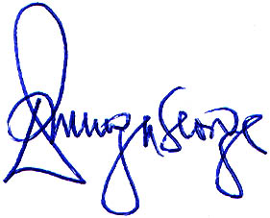

George Erwaga
Chief Executive Officer
G1 Logistics Ltd
Plot 23B, Bandali Rise, Bugolobi
P.0.Box 34960 Kampala-Uganda
Tel: +256-712-023 777
Cell: +256-772-526 516
E-mail: g1logistics@aim.com

MARKETING STRATEGY

In order to achieve success with the ADS program, a comprehensive marketing strategy will be implemented to effectively support and encourage the desired behavior change in the identified target audience.

Behaviour Change Process

The process to achieving behavior change and the communication intended to influence behavior is a process. People will move through several intermediate steps in this process. The steps that this strategy will seek to walk the target audience through are:

Knowledge/Contemplation: awareness of the problems posed by the current Class C drug stores and the desired changes needed

Approval: knowledge about and being in favor of the ADS program and its objectives

Intention: intention to personally participate in the program either as a consumer, a drug shop owner/dispenser or a policy maker

Practice: practice of the appropriate desired behavior

Advocacy: practice of the appropriate desired behavior(s) and advocate it to others

Target Audience

Primary Audience
Men and Women ages 18-45, varied educational levels, are formally employed, run their own business or are engaged in an agricultural-based work; women are mainly the ones in charge of the children’s / family’s health hence are primary purchasers of drugs;

Secondary audience
Male and female owners of the drug stores and attendants who work in the stores; are focused on running the store as a profitable business; are willing to invest further in the business as long as there is increased profit to be made; are primarily urban/peri-urban dwellers living as close as possible to their business premises; have varied educational levels; attendants are not necessarily trained in drug dispensation

Tertiary audience
Medical personnel; district and health officials: men and women aged 18-45; learned to tertiary education; most are married with families; concerned about the policies and practices governing how the district health system and resultant issues;

Media landscape
Uganda does not have a unified national language or media channel that has a 100% reach of the entire country. The radio landscape is highly segmented; and with over 40 spoken languages countrywide, it has become an industry standard to employ a cross section of media houses to attain best reach of the selected messages to the target audiences
While live broadcasts are the best at creating dialogue on health related issues, severe message fatigue also exists due to the plethora of organizations reaching the people with similar messages.

Communication Plan (Media Strategy)
The ADS program will be positioned as an initiative that cares for people through providing quality and affordable drugs. The positioning will be communicated through:
- Mass media channels: radio, signage along busy roads, boda boda advertising, billboards, point-of-sale materials at outlets, branding of ADS outlets
- Community oriented channels: launch event, use of social networks e.g. women’s groups & social clubs

Communication objectives
- Create awareness of the ADS program and its objectives
- Increase consumer awareness of the importance of buying medicines from a reliable source and taking medicines as directed
- Increase the number of consumers who buy medicines at ADSs
- Increase the number of drug store owners who sign up participate in the ADS program
- Create awareness and recognition of the ADS brand

Communication messages:

Audience | Message
Consumers (primary audience) | - ADS provides an extended list of affordable quality medicines and professional advice. (branded)  - ADS cares for you and your medicine needs (branded)  - Take the full dose of medicine to be cured. (generic)  - ADS attendants have been trained to manage many of the community’s common disease conditions.  - ADS attendants will refer patients for disease condition they were not trained to manage.  - The National Drug Authority accredits ADS to provide quality medicines and services. (generic/branded)  - Do not wait to get critically ill; seek help from a health care professional as soon as possible. (generic)  - Maintain the health of your family by listening to the advice of your health care providers. (generic)  - Ask the ADS attendant to answer questions about the medicines you are taking. (branded)  - Do not buy medicines from street vendors and hawkers. The quality and safety of their products is not known. (generic)
Shop Owners  Shop Drug sellers | - Maintain the standards and ethics of the ADS program  - Be more helpful to your community by stocking authorized quality medicines  - Maintain professional services and consumers will visit.  - Purchase medicines from wholesalers approved by the National Drug Authority (NDA).  - Access training for your attendants in order to improve the quality of services offered to your consumers.  - Refer patients to a higher level of health care if you cannot manage their condition.  - Educate your clients on how to appropriately use medicines
Community, District and Regional Leaders and Medical Personnel | - ADS means better health care and services  - District leaders; support ADS to improve the quality of medicines accessed by the community.

Mass media channel of communication

Channel selection
Given that Kibaale is a peri-urban/rural area, community based media channels within the district will be most effective for the following reasons:
Channel | Audience reached | Benefits
Local radio stations | Individuals, families | - As the stations are localized, they are more credible with the local people than the mass media stations  - Low unit cost of programming as compared to mass media stations  - Deliver frequency of messages  - Messages can be sent in the local languages  - Can engage the audience in a participatory manner through highly creative programming thereby allowing for communication of more in-depth information
Print / outdoor | Men and women with literacy abilities | - Good for identification and awareness building  - Reinforces the messages delivered through other channels  - Are visually attractive hence easily engage the audience’s attention  - Messages are brief and easily understood
Newspaper | Well educated men and women, policy makers | - Is a mass medium, usually reaching more than those in the target audience  - Variable message type and lengths

Media plan
- Radio
Research findings from the recently conducted survey done as part of this program in Kibaale identified the following stations as the most popular / frequently listened to stations:

- Radio Kagadi
- Life FM
- Hoima FM
- Radio West
Communication via radio will be instigated through:
Spot advertising: 30 second ads in both Runyakitara and English will be aired during peak hours on the selected stations
DJ Mentions: from the research findings, several DJs were identified as favorites in the district and will be engaged to endorse the ADS program during their shows on their respective stations. Message guidelines will be given to them to ensure they accurately highlight the key messages of the ADS program
Talk shows: well and respected health officials will be hosted on various radio programs to discuss in depth the ADS program. Opportunities will be given to the audience to call in and air views/opinions or questions to the show
- Billboards / wall branding
Selected strategic walls / billboard sites will be painted/placed in populous locations. The messages will be in Runyakitara, and English with prominence of the ADS branding as part of the key messages.
- Newspapers / Posters
These will be used to build synergy with radio and outdoor advertising, to inform stakeholders countrywide of the project. The print ads will mirror the billboards and will be rendered on national and local newspapers
- Press conference
Journalists from various media houses will be invited to a press conference in Kampala just prior to the project launch date. This will enable one-on-one interface with them hence providing for accurate information regarding ADS to be communicated to the broader audience in Uganda.

Media monitoring
Most of the active media houses in Uganda are registered with the Steadman Group, a research organization that provides excellent above the board reports on the performance of the media houses on all specific campaigns. The monitoring reports are submitted on a weekly basis, to enable ongoing assessment of the campaign, as well as contribute towards to final review on the impact and effectiveness of the entire media campaign.
For media houses not monitored through Steadman, in-house media logs will be required of them to validate execution of the campaign as per the contracts given to them.

Brand development:
ADS brand development is central to establishing the identity of the brand and create an understanding of what ADS represents. This will involve:
- Development of the ADS logo and its use in all branding and promotional materials
- Selection of the design of the ADS outlet branding
- Translation of the ADS brand onto all marketing materials including:
  - Posters & fliers
  - Brochures
  - T-shirts
  - Caps
  - Branded doctor’s coats (for dispensers)
  - Outdoor signage (billboards, ABS boards for the outlets, signposts, banners)

ADS Initiative Launch Event

Event objectives
- Create awareness of the ADS program and its objectives in Kibaale district
- Bring together representatives of key stakeholders and associated organizations to officiate the official program launch
- Officially open the ADS outlets in Kibale town
- Celebrate the program launch with much pomp and hype to make it a memorable event and start off the program operation on a high note

Launch Plan
The launch of the ADS Initiative will be an open-air one-day event celebrated in Kibale town, scheduled to take place on 12th Nov, 2009.
Participants will include:
- Guest of Honor—Minister of Health; Dr. Steven Mallinga
- Representatives of NDA, PSU, MOH, MSH and other partner organizations directly involved in the project
- Senior district officials
- Senior MOH and other health officials from the district
- Community members

The event will be preceded by a mobilization drive around key towns in the district, creating awareness of the event as well as mobilizing the people to attend. The event will make use of information networks such as local radio stations, district health teams to communicate the invitation to attend the event.( Major towns to be covered include Kibaale, kagadi, & kakumiro)

The event activities will include:
- Keynote address by the Guest of Honor, Senior District and Health officials
- Edutainment (education through entertainment) by an experiential marketing team who will educate the audience on key issues that ADS program will address in the distric
- Testimonials from community members on their experiences with drugs access in the local drug stores
- Testimonials from drug store owners who will have upgraded their stores to ADS outlets
- Entertainment by local dance groups including song performances, dance routines, local comedy skewed to the experiences within the region
- Training the audience on an ADS anthem song that will have been produced by a celebrated local artist
- Media coverage (photography & video) of the event to ensure coverage in print and radio news

Prior to the event, the program branding within the district will have been put in place i.e.
- Billboards
- Posters on strategic outlets
- Road signs
- Wall branding

The program advertising on radio and newspapers will be ongoing

Event/launch progress Check list
An event/launch progress check list will be ticked off with the focal person at the end of every week and will be the framework for reporting. All items undone within 7 days to the launch will have a red flag raised against them and all relevant levels of the MSH team will be updated with reasons for these delays given.
Video Coverage and Audio
In order to have all proceedings recorded well on video, we recommend the use of video lights and 3 video cameras. There is need to have a camera focused on presentations / Panel, one on the participants (questions / contributions) and another doing fillers. In addition to audio recording, the two steady cameras will help the rapportuers capture all information like who spoke, where they came from and what exactly they said (quoting verbatim).

Community Outreaches

Community group activations will be instrumental to engaging the community members to train them on the essence of the ADS program and how it will positively affect their lives. The activities will include:
- Edutainment events such as:
  - Road shows: A rig branded with ADS banners and music system, playing the ADS anthem will move from town to town mobilizing the community members and engaging them on the new initiative. ADS outlets within the town will be prominently identified by name and promoted as examples in the community to encourage the members to obtain their drugs from those outlets
  - Social clubs activations
A team of trained facilitators will visit the various villages and trading centres etc, in the mornings and engage the audience on the ADS program. Through dialogue and Q&A session, issues such as what is ADS, how is it different from other drug stores, correct drug usage etc will be discussed in an engaging and educative manner. IEC materials will also be distributed to the audience.
In the afternoons, the teams will mobilize existing social network group s such as women’s groups and have similar interactive sessions with them on the ADS initiative
The community outreach program will run for several months after the launch date to cement the impact of the launch event.

ANNEXES

ANNEX 1: EVENT SITE PLAN-VENUE SET UP

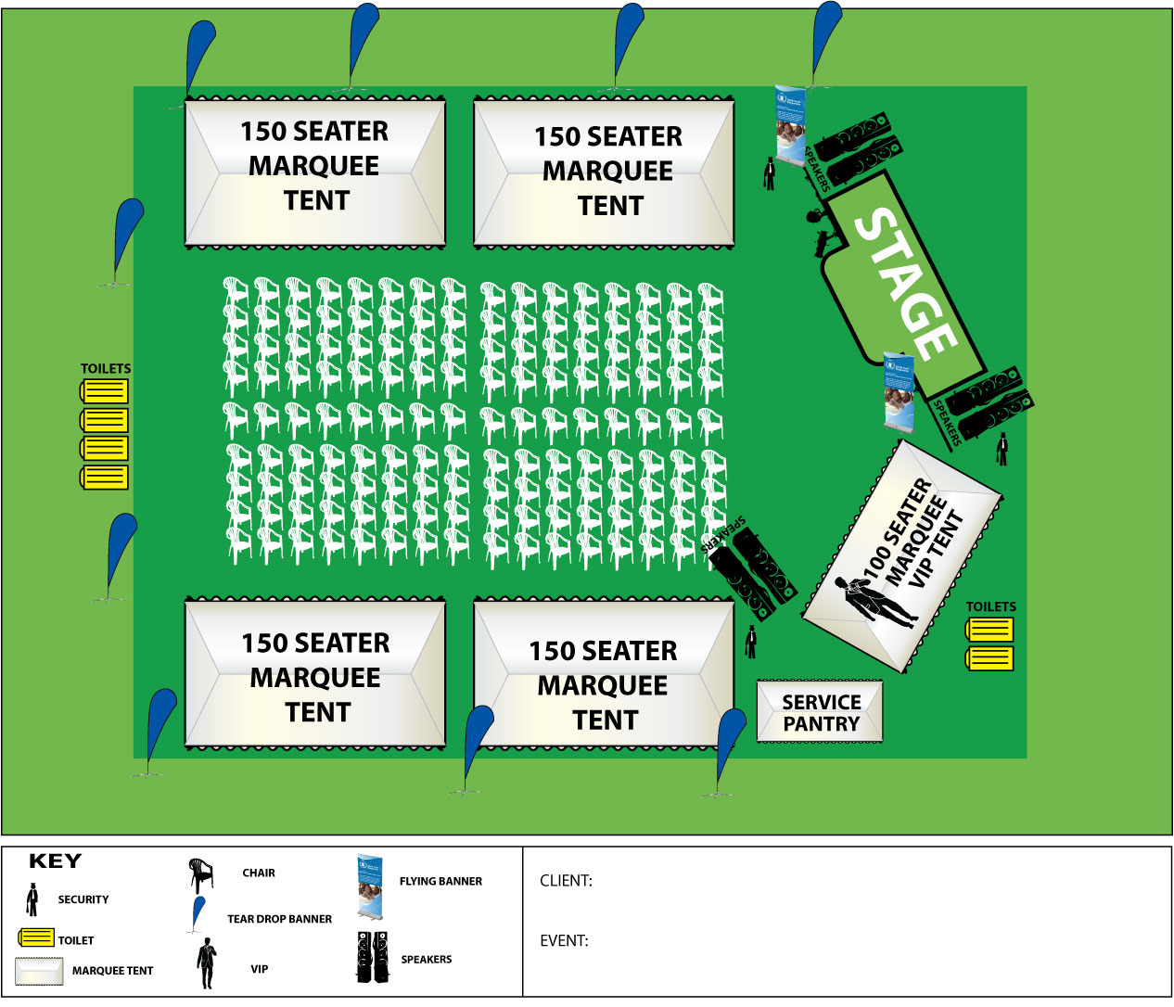

ANNEX 2: STAGE/PLATFORM

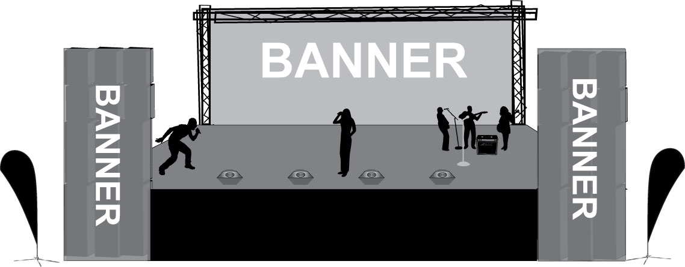

ANNEX 3: EXECUTION PLAN

The sequential execution of the marketing strategy will encompass the following steps:

- After approval of the marketing plan the consultant will develop the creative brief for the development of the artwork for the logo and all branding materials.
- The first drafts will be submitted within one week.
- G1/MSH will test the logos, brand names and artwork by conducting 2 or 3 focus group discussions.
- Approval of the logos and brand names will be sought from NDA.
- Once the brand name has been selected, the creative department will make necessary changes and adapt the artwork to the promotional items such as t-shirts, cups, umbrellas and outdoor billboards.
- G1 will source for quotations from the billboard companies that have sites in Kibaale district. Once a billboard agency has been chosen and specifications for the billboards selected, the advertising agency will adapt the artwork to meet those specifications and give the artwork to the outdoor company.
- G1 will supervise production of the promotional items based on the approved artwork.
- G1 will brief the interpersonal communication team who will conduct the launch, road shows and the community interpersonal communication in the district.
- The launch will be conducted followed by the IPC activities in the subsequent weeks.
- Feedback from the evaluation process will be collected
- Weekly status review meetings/reports (The G1 team will meet MSH team with the relevant stake holders every week to review and assess progress of work)
- Final marketing execution report will be prepared and submitted

Report Writing
Within three working days, the first draft of the transcription / minutes will be delivered to MSH. Additionally, 5 working days after the Launch, we shall present a draft report, photos and semi-edited video footage to be discussed during the debriefing and thereafter allow for two reviews interspersed with corrected drafts to ensure that the final report is agreed by all levels of MSH structures.

