

**Draft Strategy on**

**Consumer Engagement and Branding for BPMI Project**

**Prepared by:**

**Visual Communication Ltd. (VISCOM)**

**July 2016**

**___________________________________________________________________________________________________________________________________________________________________________________________________________________________________________________________________________________________________________________**

**List of Contents**

**Acronyms**

1. **Background of Strategy Development**

**1.1 Introduction**

**1.2 Rationale**

**1.3 Research Questions**

**1.4 Objectives**

**1.5 Target Audience**

1. **Methodology of Strategy Development**

**2.1 Principles Followed**

**2.2 Steps taken as per SoW**

**2.3 Field Data Collection**

**2.4 Findings considered for Strategy**

1. **General Part of the Strategy**

**3.1 Guiding Principles**

**3.2 Problems Addressed**

**3.3 Core Components**

**3.4 Major Partners of Strategy**

1. **Consumer Engagement Strategy**

**4.1 Principles followed to Design the Strategy**

**4.1.1 Steps of BCC**

**4.1.2 SMART Approach to BCC**

**4.1.3 Communication Approaches to support BCC**

**4.1.4 Types of BCC Materials to be considered**

**4.1.5 Message Development**

**4.1.6 Material Development and Utilization**

**4.2 Recommendations from Needs Assessment Study**

**4.3 Consumers’ Rights and Responsibilities**

**4.4 Proposed Strategy for Rational Use of Medicines**

**4.5 Consumer Engagement Strategy in Matrix Form**

1. **Branding/Marketing of Model Pharmacies**

**5.1 Retail Pharmacies and Dispensers in Bangladesh**

**5.2 Feasibility of Developing Model Pharmacies in Bangladesh**

**5.3 Recommendations from Needs Assessment Study**

**5.4 Branding Strategy in Matrix Form**

1. **Conclusion/Recommendations**
2. **References**
3. **Appendices**

**ACRONYMS AND ABBREVIATIONS**

|  |  |
| --- | --- |
| **ACSM** | Advocacy, Communication and Social Mobilization |
| **ADS** | Accredited Drug Seller |
| **AHUB** | Ayurveda, Homeopathy, and Unani Board |
| **AMS** | Accredited Medicine Stores |
| **BAPI** | Bangladesh Association of Pharmaceutical Industries |
| **BCC** | Behavior Change Communication |
| **BCDS** | Bangladesh Chemist and Druggist *Samity* |
| **BPMI** | Bangladesh Pharmacy Model Initiative |
| **BPS** | Bangladesh Pharmaceutical Society |
| **CAB** | Consumer Association Bangladesh |
| **CM** | Community Mobilization |
| **DGDA** | Directorate General of Drug Administration |
| **DGFP** | Directorate General of Family Planning |
| **DGHS** | Directorate General of Health Services |
| **DI** | Drug Inspector |
| **DS** | Drug Superintendent |
| **FGD** | Focus Group Discussion |
| **IEC** | Information Education and Communication |
| **II** | Individual Interview |
| **IPC** | Inter Personal Communication |
| **KII** | Key informant interviews |
| **MRP** | Maximum Retail Price |
| **MSH**  **MSOA** | Management Sciences for Health  Medicine Shop Owners’ Association |
| **NA** | Needs Assessment |
| **NGO** | Nongovernment Organization |
| **OTC** | Over the Counter |
| **PCB** | Pharmacy Council Bangladesh |
| **RMP** | Rural Medical Practitioner |
| **SDSI** | Sustainable Drug Seller Initiative |
| **SIAPS** | Systems for Improved Access to Pharmaceuticals & Services |
| **SMC** | Social Marketing Company |
| **TWG** | Technical Working Group |
| **UHC** | Upazila Health Complex |
| **UZ** | Upazila |
|  |  |

1. **Background of Strategy Development**
   1. **Introduction**

In Bangladesh availability of quality medicines in retail pharmacies including services provided by the dispensers is one of the major problems affecting public health. To address this issue, MSH (Management Sciences for Health) has initiated a project titled Designing Implementation Strategy for Accredited Drug Seller (ADS) model in Bangladesh. In developing the Bangladesh Pharmacy Model Initiative (BPMI) program, MSH aims to strengthen the capacity of the Directorate General of Drug Administration (DGDA) and the Pharmacy Council of Bangladesh (PCB) to ensure improved access to and appropriate use of quality medicines and pharmaceutical services through accreditation and monitoring of private sector drug shops and pharmacies. This project encompasses the first eight-month phase of work that includes preliminary model development, planning for targeted district implementation and evaluation, and capacity building of national institutions to move the BPMI implementation phase forward.

MSH has selected Visual Communication Ltd. (VISCOM) as consultant to develop a consumer engagement strategy, including consumer advocacy and marketing and branding components, which can be implemented during the BPMI implementation phase.

**1.2 Rationale/Justification of the Strategy**

Retail medicine shops are the preferred first point of contact for a majority of the population in developing countries including Bangladesh. Currently in Bangladesh, more than 1,30,000 licensed retail medicine shops and approximately an equal number of unlicensed such shops are involved in selling medicines “over-the-counter.” Most of the salespeople and dispensers at those retail medicine shops do not have training in dispensing medicines or in offering diagnoses and treatment, which they frequently do.

Because those medicine shop salespeople have no other channel of information beyond the formal sectors open to them, they fall easy prey to the aggressive marketing strategies of the pharmaceutical companies. Irrational use of medicines such as overprescribing, multidrug prescribing, using unnecessarily expensive medicines, dispensing medicines without a prescription, and overusing antibiotics and injections have been the most common problems found with those retail medicine shops for a long time.

Given the importance of the informal sector, including retail medicine shops in Bangladesh, improved regulation of this sector offers an important opportunity to improve community health. Experiences in other parts of world have demonstrated that private-sector medicine seller initiatives that are based on an accreditation and regulation model are feasible, improve access to medicines, and can be scaled up. The strategy is needed to fill in the knowledge gaps about those unregulated medicine shops in the private sector and about management of them through the informed design of an accredited medicine shop model named Bangladesh Pharmacy Model Initiative (BPMI).

**1.3 Research Questions of Designing Strategy**

The essential questions that guided strategy development were as follows:

1) Do the retail medicine shops in Bangladesh meet the legal and regulatory standards—such as having valid business licenses and registrations to sell medicines—for operating the business?

2) What are the opportunities for an accreditation program for medicine shops and drugstores to improve access to quality medicines and pharmaceutical services in Bangladesh?

3) What are the availability, affordability, and quality (assessed according to the expiration date, packaging status, and drug storage conditions) of essential medicines circulating in the private retail pharmaceutical market in Bangladesh?

4) What are the perceptions of the community, medicine shop owners, and regulators regarding medicine shops? What are their perceptions regarding the acceptance of regulations?

5) What is the feasibility of implementing accreditation strategies in Bangladesh as assessed in part through (1) medicine seller or owner interest in licensing the shop and (2) key informant perception of accreditation, including perceived benefits and barriers to implementation?

* 1. **Objective**

Overall objective was to design a strategy on Bangladesh pharmacy model to create a brand awareness of BPMI accredited medicine shops by consumer engagement activities that would ensure quality of drug product, right dose of drug and/or affordability of standard services with direct engagement of consumers.

**Specific objectives are:**

* To develop a strategy for engaging consumers in ensuring the quality, appropriateness, or affordability of the pharmaceuticals/services provided in their communities.
* To create brand awareness and marketing of BPMI accredited pharmacies.
* To strengthen marketing efforts/campaign to promote newly accredited drug shops through program launch events, local radio messages, branding materials (print and outdoor) and sustained community media.
* To strengthen the capacity of the Directorate General of Drug Administration (DGDA) and the Pharmacy Council of Bangladesh (PCB).
* To ensure improved access to and appropriate use of quality medicines and pharmaceutical services in Bangladesh through accreditation and monitoring of private sector retail medicine shops.

**1.5 Target Audience:**

1. **Primary Audience** -(Demand side)
2. - Consumers of medicines and potential consumers (mass people of the community.
3. **Secondary Audience** (Supply side)

- Medicine sellers and medicine shop owners both rural and urban.

**c) Tertiary Audience** (Regulatory bodies)

- Stakeholders at 3 levels such as: Central, District and Upazilla

**S2. Methodology Followed**

* 1. **The P-Process**

Our Methodology for developing Consumer Engagement Strategy with Branding Component for the target audiences of all level followed globally practiced Conceptual Frameworks for Strategic Communication (*Source: Johns Hopkins University, Center for Communication Programs)*. This Framework of social communication has 5 specific steps which are:

1) Analysis, 2) Strategic design, 3) Development, pre-testing, revision and production, 4) Management, Implementation and Monitoring, 5) Impact evaluation and Replanning. For this project we will only focus on first 2 steps.



* 1. **Involved Steps to develop the strategy**

As per agreed Scope of Work (SoW) following steps were followed.

1. Reviewed marketing plans and consumer advocacy materials and strategies from Tanzania, Uganda, and Liberia.
2. Planned to work with consumer advocacy technical working group to introduce the assignment and plans for developing the BPMI consumer advocacy strategy.
3. Conducted key informant interviews and/or focus group discussions with stakeholders knowledgeable about pharmacy branding and consumer advocacy and engagement activities in Bangladesh at the central and district level.
   1. Central level interviewees included: DGDA, PCB, BCDS, BAPI, Pharmacy Dept. Of DU, SMC and other experts in this field.
   2. District and Upazila level interviewees include: Key Informants (from DGDA, BCDS and others), pharmacy owners and dispensers, consumers and potential consumers.
4. Met with Consumer Association of Bangladesh (CAB) to seek their inputs and review their existing strategies and activities.
5. Prepared report on needs assessment survey compiled from findings through data collection from Dhaka and three selected areas of the country.
6. Based on the experiences of other countries, information gathered from stakeholders and other target audiences (NA report), developed a draft concept note describing a proposed BPMI consumer engagement strategy including:
   1. Consumer engagement strategy, including identified problems, plausible solution, description of steps required, materials to be developed and challenges faced, recommended key players, and approaches for implementing and evaluating the strategy components.
   2. BPMI accredited pharmacy marketing and branding strategy, including description of existing problems and actions/resources required.
7. Planned a consumer engagement strategy technical working group meeting to solicit stakeholders’ feedback on the concept note.
8. Based on stakeholders’ feedback, the concept note will be revised to propose a final BPMI consumer engagement strategy.
9. Finally draft consumer engagement strategy will be proposed to a broader group of key stakeholders to make its Final Version with approval.

**2.3 Data Collection Fields and Methods**

**Sampling/Sample Size of Target Audience**

Formative Research for needs assessment was conducted in 3 selected districts and Khilkhet thana of Dhaka City through 8 FGDs and 78 Individual Interviews. Data was collected from a total of 158 participants (FGD 10X8= 80 persons and IIs 78X1=78 persons). FGD Guideline and Questionnaire of 6 types for Individual Interviews were developed and finalized after revision to collect relevant information from target audience and key informants.

Information was collected on socio-demographic status of the respondents, present knowledge and awareness level, concept of quality medicine and services, pharmacy types in the locality, their legal status, present practice/barriers faced by consumers and dispensers, their needs/expectations, ways to reach the desired level of ADS, Idea on branding/promotional materials, capacity building of service providers and other suggestions were considered to design consumer engagement and marketing strategy.

**Locations of Data Collection**

Data was collected from primary and secondary audiences of 4 selected locations which are Dhaka (Khilkhet area) and 3 other districts (Moulvi Bazar, Kurigram and Chandpur) representing different regions of the country. Data was also collected from tertiary audience (Key informants) at central and local level including district and upazillas. (Please see annex)

|  |  |  |  |  |  |
| --- | --- | --- | --- | --- | --- |
| **Sl No.** | **Location/District/**  **UZ with Dates** | **Types of Audience** | **Individual Interviews** | **FGDs** | **Total Respondents** |
| 1. | Dhaka (Central)  8th -12th May, 2016 | Tertiary/Key informants (KI) | 10 Central KI  Total=10 |  | 10 |
| 2. | Dhaka (Khilkhet)  14th -19th May, 2016 | Primary & Secondary | 5 Consumers  + 5 Dispensers  +4 Shop owners  Total=14 | 2 Groups of  10 Potential Consumers  Total=2 FGDs | 34 |
| 3. | District 1  Moulvi Bazar &  UZ: Kulawara  14th -19th May, 2016 | Primary,  Secondary & Tertiary | 5 Consumers  + 5 Dispensers  +4 Shop owners  2 District KI  2 Upazilla KI  Total=18 | Same as above  Total=2 | 38 |
| 4. | District 2  Kurigram &  UZ: Nageswari  14th -19th May,2016 | Primary,  Secondary & Tertiary | Same as above  Total=18 | Same as above  Total=2 | 38 |
| 5. | District 3  Chandpur &  UZ: Hajigonj  14th -19th May, 2016 | Primary,  Secondary & Tertiary | Same as above  Total=18 | Same as above  Total=2 | 38 |
|  | **Summary** |  | **Total= 78** | **Total= 8** | **158 Respondents** |

**2.4 Summary Findings of Needs Assessment Study**

Following findings derived from key stakeholders and respondents from four selected geographical locations were taken in to consideration to design the strategy.

**Consumer responses**

* Consumers are conscious about quality and effective medicines.
* They should always buy medicines (except approved OTC medicines) as per prescription given by registered physician.
* They should look for reputed company and check expiry date while buying medicines.
* They should always ask about dosage, duration of medicine intake and possible side effects from dispensers.
* Consumers should not be given fake and expired medicines.
* If possible, they should buy medicines from model pharmacy.
* Monitoring needs to be strengthened. Stronger monitoring needed to guard against fake and sub-quality medicines.
* Dispensers and shop owners should be first motivated to give better service

**Dispenser /Pharmacy owner responses**

* Presence of qualified/trained pharmacists must be ensured in all model pharmacies.
* Medicine shops (Level-2) should have dispensers with Grades B or C, while Pharmacies (Level-2) should have dispensers with Grade A.
* Financial and infrastructure help are necessary for medicine shops.
* All medicine shops should have refrigerator for temp. sensitive medicines and if possible, AC.
* Price should be mentioned of all medicines on each strip to avoid overpricing.
* Other health promotional items should be allowed to sell to ensure their business viability.
* There should be good relationship between dispensers and consumers.
* Companies should arrange orientation sessions for them before marketing new products.
* Local pharmacies should get medicine supply directly from reputed companies to ensure good quality medicines.

**Key informants’ responses**

* Key informants were interviewed at 3 levels such as: central, district and upazilla. Organizations covered were DGDA, PCB, BCDS, CAB, Pharmacy Faculty of DU, ADS Consultants, MSOA and others.
* Govt. (DGDA) should strictly control quality of medicines which are marketed by different companies.
* Companies should be banned which produce fake and sub-quality medicines.
* Financial support with long term loan under easy conditions should be given to pharmacies included in BPMI program.
* DGDA and other regulatory bodies should be more alert to control quality of the medicine shops.
* Above all, everyone’s moral and spirit should be high and not selfish to make profit at the cost human misery and lives.

1. **General Part of the Strategy**

The marketing and branding of BPMI accredited pharmacies will complement the consumer engagement advocacy activities. The BPMI pharmacy brand will identify those medicine dispensing outlets that meet Bangladeshi regulatory requirements and indicates that the shop has a BPMI trained dispenser and provides quality medicines and pharmaceutical services. In some other countries marketing efforts to promote newly accredited drug shops have included program launch events, local radio messages, branding materials such as bill boards, signboards for the shops, coats, hats, and posters, and sustained community media and marketing campaigns.

**3.1 Guiding Principles of the Strategy Designing**

The Strategy utilized following guiding principles:

**Integrated:** Integration within the other components of BPMI project and among BCC activities so that synergy is created by strategically using multiple communication channels (mass media, community-based, and interpersonal) to reinforce one another and maximize impact.

**Use of Determinates:** A key to changing behaviors is developing an understanding of motivators and barriers of behavior change and using this information to design activities and messages.

**Results-oriented**: The effectiveness of a BCC effort will be ultimately determined by outcomes; increased knowledge and the adoption of positive behaviors will be verified by research and monitoring.

**Consumer-centered:** A consumer centered approach involves clients in the determination of their needs and engages them in the process of shaping messages that address those needs. A recognition that individuals do not change alone but empowered households and communities play a key role in creating a supportive environment for the desired change.

**Participatory:** All stakeholders are involved at every step in the strategic communication process, including program design, implementation, and evaluation.

**Audience Segmentation:** Audience segmentation is very important as it allows for more tailored messages to audiences and a focus on which target groups are most vulnerable. Analysis is conducted of what type of messages will be meaningful to each target group, which communication media would best reach the target group.

**Multi-channeled:** The use of complementary channels or ways to reach target audiences has been shown to increase the effectiveness of BCC.

**Technical quality:** BCC activities will aim for high-quality messaging and products and will use accurate data and theory to inform and guide activities. All BCC activities and messages will be synchronized and aligned with relevant government and ministry policies and strategies.

**Recognition of the stages of behavior change**: Various strategies are required to increase knowledge, promote essential attitude change, create a demand for information and services, improve skills and a sense of self-efficacy, and advocate for change in others

**Advocacy-related:** BCC activities will target household, community, and policy levels to influence social and behavior change in favor of rationale use of quality medicines.

**Sustainable:** BPMI program should aspire to create sustainable social change by motivating social, cultural, religious, governmental and other stakeholders to include information, promotion, and advocacy on their agendas, and increasing the capacity of local partners to carry out BCC activities on their own.

**Cost effective:** Resources will be focused towards a combination of the most cost effective channels aimed at changing social conditions and individual behaviors.

* 1. **Issues addressed in formulating the strategy**

**General**

* Improve availability, quality of medicines in retail medicine shops.
* Improve service and accessibility to local pharmacies for consumers.
* Ensure that medicine shop has a PCB trained dispenser of at least Grade C.
* Help ensure pharmacy compliance to regulatory requirements and quality products.
* Intensive monitoring of the registered pharmacies for quality control.
* Strengthen the capacity of DGDA and the Pharmacy Council of Bangladesh (PCB).

**Consumer Engagement**

* Improved access to and appropriate use of quality medicines and services
* Encourage appropriate use of dispensed medicines, and demand quality services.
* Create awareness of the BPMI program and BPMI pharmacy brand in the community.
* Look for model pharmacies for medicines and health services from trained dispensers.

**Branding of Model Pharmacies**

* Brand pharmacy to identify medicine outlets that meet BD regulatory requirements.
* Opinion/suggestion on Branding -BPMI accredited drug shops owners idea on:

electronic (local and national radio messages, TVC etc.), print media (newspaper, posters, signboards, billboards ), promotional materials (logo, T-shirt, coats, hats with suitable messages), seminar, symposium etc.

* Display of certificate of legal papers/registration of pharmacy, received training by the dispenser etc.
* Strengthen marketing efforts/campaign to promote newly accredited drug shops.

**3.3 Core Components of the developed Strategy**

**Advocacy:** Advocacy will seek to ensure that government remains strongly committed to implementing BPMI control policies guided by DGDA. Policy advocacy through round tables will inform senior politicians and administrators how rational use of medicines will affect public health, and will outline actions to take to improve laws and policies in this regard. Program advocacy will target opinion leaders at the community level through orientation meetings on the need for local action. Media advocacy in newspaper, TV and radio will strengthen the relevance of BPMI issue on the public agenda, and will encourage the media to cover model pharmacy related topics regularly to raise awareness at all level.

**BCC:**  Behavior-change communication (BCC) will aim to change knowledge, attitudes and practices among various groups of people, specially medicine consumers. It will frequently inform the public of the services available in model pharmacies under the project with series of messages on availability of quality medicines and services under qualified dispensers such as; ‘Get your medicines from model pharmacies’, ‘Seek for advice from dispensers, when you buy medicines’ etc. For this awareness campaign multi-channel approach will be followed involving print, outdoor and electronic media.

C**Community Mobilization:** Community mobilization (CM) will bring together community members and other stakeholders to strengthen community participation for sustainability of BPMI program. Social mobilization will generate dialogue, negotiation and consensus among a range of players that includes decision-makers, the media, NGOs, opinion leaders, policy-makers, the private sector, professional associations (BAPI, BCDS, PCB, CAB etc.). Seminars, workshops, rallies, road shows etc. on BPMI will be arranged to orient local influential people and increase community awareness on rational use of medicines from standard outlets like model pharmacies.

**3.4 Major Partners of BPMI**

* Organizations like DGDA, PCB, BAPI, CAB, BCDS etc. can play important role. Support of govt. (MOHFW) would be necessary in all steps.
* Administrative and health service staff of the govt. set up can contribute to promote the program at district, upazilla and union level.

1. **Consumer Engagement Strategy**

**4.1 Principles Followed to Design the Strategy**

In order to develop Consumer Engagement Strategy and its implementation for BPMI project emphasis was given on Behavior Change Communication of the primary target audience who are the consumers.

The first step in developing a BCC Strategy is to clearly define the priority behaviors which the project will address. Behaviors are defined as observable, measurable, and concrete actions that are clearly tied to the expected outcome (e.g. increased awareness, attitudinal change, practice and advocacy).This step, as with all steps in developing this strategy, is a continuous process, and should be revisited as project priorities change.

**4.1.1 Steps of BCC**

To design strategic communication programs that are appropriate for public health issues JHU/CCP developed a theoretical framework termed the Steps to Behavior Change (SBC). It consists of five major stages of change which are: Knowledge, Approval, Intention, Practice and Advocacy. Steps of Behavior Change (KAIPA) that we propose to follow are as follows:

**Five steps associated with the process of behavior change -**

**Knowledge:** To aware target audience on advantages of quality medicines and services from model pharmacies.

**Approval:** To respond favorably to the disseminated messages through different media.

**Intention:** To be convinced for choosing model pharmacies for better service.

**Practice:** Go to suitable service outlet and dispenser for procuring medicine with confidence.

**Advocacy:** Acknowledge personal benefit of rational medicine use and advocate same practice to others.

**4.1.2 SMART approach for BCC**

We followed globally practiced **SMART** approach for formulating the consumer related strategy.

Set Objectives were SMART as mentioned below:

**Specific:** Defining what is to be accomplished in terms of specific steps of BCC among well defined audiences.

**Measurable:** Quantifying objectives by indicating numerical or percentage change expected.

**Appropriate:** Defining indicated changes that are locally and culturally acceptable.

**Realistic:** Avoiding objectives that are beyond the scope of available resources and unrealistic to communication efforts.

**Time bound:** Identifying the time frame in which changes should be achieved.

**4.1.3 Communication approaches to support BCC**

To support Behavior Change of the target audience following components were also considered to develop the strategy.

* Advocacy
* Community mobilization
* Interpersonal communication
* Edutainment (Education-Entertainment)
* Mass media

|  |  |  |  |  |
| --- | --- | --- | --- | --- |
| **Interpersonal Communication (IPC)** | **Community Mobilization (CM)** | **Advocacy** | **Education Entertainment (EE)** | **Mass Media (MM)** |
| One-to-one, small groups provide an opportunity to talk and discuss issues.  This process is one of the most powerful tools for BCC as it involves satisfied clients. | Community participation builds ownership by the community and encourages sustainability.  CM is essential for desired practices to become “normal behavior” in the community. | Advocacy is needed to influence decision makers at all levels to provide commitment, resources, policies, and organizational support.  Advocacy is good for “selling” behaviors through the use of role models and their power of persuasion. | This approach presents opportunities to build a sense of fun and excitement. It gives serious messages in a light way,  EE provides a good avenue for role modeling behavior. | Community radio , television, theater, fairs, and printed materials are always effective to reach a large audience and influence behaviors.  Mass media can be closely linked with EE, and reinforce other communication efforts. |
|  | | | | |

**4.1.4 Types of BCC Materials and Media to be considered**

**Print Media:** Poster, Leaflet, Brochure, Booklet, Flipchart, Dangler, Flash Card, Desk Calendar, Wall Calendar, Flyer, Newspaper, Information Card, Newsletter etc.

**Outdoor Media:** Billboard, Sign board, Wall Painting, Banner, Festoon, Tin Sign etc.

**Electronic Media:** Television, Radio, Internet, Local Cable Channels

**Social Media:** SMS service, Face book and other Social Media

**Community Media:** Community Sensitization Meeting, Group Meeting, Counseling, Peer

Education, Education Institution Based Meeting, Street Theater, Folk media, Community Radio, seminar, rally etc.

***Media Mix*** *is a communication approach that utilizes multi-channel (print, electronic, outdoor etc.) and multi-level interventions to achieve the desired objective. This approach is very effective that has long lasting impact.* *The strategy has suggested media mix method.*

**4.1.5 Message Development**

Message development for BCC materials is an integral part of the Consumer Engagement Strategy. The development of messages is a systematic an important process. The BCC Strategy identifies potential message content that needs to be refined and aligned with appropriate channels or materials based on the target audience.

The BCC frameworks indicate message content only not the complete message. This is another exercise through appropriate process of message and material development to finalize and message and fit in at appropriate materials. Skill of relevant personal developed to follow the process and validate with appropriateness for the specific target audience.

The main feature of the message and materials development for BPMI’s BCC Strategy is the development of “core” – or base – messages that build upon findings from the qualitative investigation, and seek to ***promote benefits, address barriers and enhance enabling factors***to change behaviors*.* Messages will focus on the key behavior change or each identified problems of consumers and dispensers. Following points must be considered to formulate effective messages. As such, messages should have **7 Cs** –

|  |  |
| --- | --- |
| **7 Cs** | **Elaboration** |
| * Command Attention | Are noticed, Stand out in the clutter |
| * Clarify the message | Keep it simple & direct |
| * Cater to the Heart and Head | Offer emotional values |
| * Communicate a benefit | Tell people how it helps them |
| * Create Trust | Establish believability |
| * Call for Action | Ask people to do something |
| * Consistency Counts | Repeat to help them remember |

**4.1.6 Materials Development and Effective utilization**

The materials selected for the BPMI BCC strategy will be meant to work in synergy with existing materials in Bangladesh in order to support and complement community mobilization and interpersonal communication activities All developed messages will ensure **5Rs** which are: **Right message** should reach **Right audience** through **Right channel** at **Right time** by **Right person**. According to materials character message need to be incorporated and ensure the target audience focus. Effective utilization required to ensure return on investment. A plan for the dissemination of materials will be phased-in according to the program implementation plan. Periodic monitoring by program person will ensure effective utilization. Every materials or tools would require a guideline for utilization.

* 1. **Recommendations from Needs Assessment Study**

**Consumer related**

* Consumers should always buy medicines (except OTC) with proper prescription.
* They should check expiry date while buying medicines.
* They should always ask about dosage, duration of medicine intake and possible side effects.
* Further suggestions were: set up more model pharmacies, do mobile counseling etc.
* They should look for model pharmacies to buy medicines and get services.
* They should be made aware of advantages of model pharmacies through different media.

**Dispenser/Medicine shop related**

* Proper training should be given to dispensers by the authority (PCB).
* All model pharmacies must be run by trained pharmacists from PCB. They should have clear idea of the pharmaceutical companies and their products.
* Dispensers should follow ‘First expiry, first out’ rule while selling medicine to exclude expiry of medicines.
* Dispensers should be allowed to sell other health promotional items for business viability.
* Financial and infrastructural helps are necessary for medicine shops.
* Medicine shops should have refrigerator for temp. sensitive medicines and if possible, AC.
* Dispensers should not dispense sub-standard, fake and expired medicines.
* There should be generator/IPS support to ensure constant power supply.
* There should be good relationship between dispensers and consumers.
* There should be intensive branding of model pharmacies in communities.

**Regulation related**

* Monitoring needs to be strengthened. Stronger monitoring needed to guard against flow of fake and sub-quality medicines.
* Supply chain (production, distribution and outlet) should be managed properly.
* If anomaly is found in pharmacies, lawful steps should be taken by the authority.
* Lawful steps should be taken against companies producing sub-quality medicines.

**4.3 Consumers’ Rights and Responsibilities for BPMI Program**

Consumers’ rights and responsibilities are considered with due importance while formulating the strategy its implementation including message and material development for desired behavior change.CAB can take necessary steps to ensure consumers’ right by orienting people and developing a monitoring system to regulate rational use of medicines safeguarding them.

**Consumer Engagement Strategy:** Strategy will be sound if consumers are aware of their rights and responsibilities while using pharmaceutical products and availing services at model pharmacies. The following are various consumers’ rights and responsibilities.

(i) **Right to safety:** Consumers have a right to be protected against marketing of goods which are injurious to health and life. Consumers can complain against the dealer, retailer, manufacturer and even claim compensation.

(ii) **Right to be informed:** Consumers also have the right to be informed about the quantity, quality, purity, standard or grade and price of medicines available so that they can make proper choice before buying any medicine or service.

(iii) **Right to choose:** Every consumer has the right to choose medicines needed from a wide variety of similar medicines and services. Very often dealers and traders try to use pressure tactics to sell medicines of poor quality.

**(v) Right to seek redress:** If and when any consumer has a complaint or grievance due to unfair trade practices like negligence caused adverse effects, charging higher price, selling of poor quality or unsafe medicines, he has the right to seek remedies from dispensers/medicine shop owners.

**(vi)** **Right to consumer education:** To prevent market malpractices and exploitation of consumers, consumer awareness and education are essentially required. For this purpose, consumer associations, Health educational institutions and Government policy makers are expected to enable consumers to be informed and educated through multi-media campaign on rational use of medicines.

**4.4 Proposed Strategy for rational use of medicines**

The process of eliminating inappropriate use of medicines has something to do with measures to support rational use of medicines most specifically for consumer to change their attitude and behavior when using medications.

The core part of changing consumers’ behaviors is based on the messages, facts and figures

going to be shared to consumers.

The core messages to eliminate inappropriate use of medicines through enhanced consumer behavior, communication activities including;- promoting consumer engagement activism to encourage the appropriate use of dispensed medicines thereby minimize the risks of drugs resistance at community level.

The designed messages will address concerns relating to irrational use of medicines, search for model pharmacies and qualified dispensers, ask for proper counseling, look for certification displayed in medicine shops and their consumer rights. These all will lead to their behavior change over a period of time.

Consumer education is about narrowing the knowledge and skills gaps on using medicines rationally with sufficient knowledge about the risks and benefits of using various medicines.

Consumer education highlight tips on when and how to use medicines to ensure that consumer often gets the expected clinical outcomes and avoid adverse effects. This is for prescribed medicines, as well as medicines used without the advice of health professionals.

This will further require that:

The consumer engagement strategy and its campaign need to ensure that over-the-counter medicines are sold with adequate labeling and instructions which are accurate, legible, and easily understood by lay persons.

**4.5 Proposed Consumer Engagement Strategy in Matrix Form**

Considering responses and perspectives from all categories such as consumers, dispensers/shop owners and key informants of three levels and subsequent meetings following findings/problems with proposed actions are compiled on five specific aspects. Major areas are: **Availability and Quality of Medicines, Accessibility to Service, Counseling, Consumers’ Rights and Risky Practices affecting consumers.** This strategy could be adopted during pilot phase covering 5 divisions and 3 districts of the country.

|  |  |  |  |  |
| --- | --- | --- | --- | --- |
| **Major Areas** | **Identified Problems** | **Solution** | **Action/Communication Interventions** | **Remarks/**  **Challenges** |
| **1. Availability and Quality of Medicines** | **1.1 Substandard medicines.**  Substandard medicines  In existing retail medicine shops. | Consumers to be informed through different media on presence of ADS where standard medicines are available | BCC through  1.Print media (poster, leaflet, brochure etc)  2. Outdoor media (signboard, billboard, wall painting, banner etc.)  3. Electronic media (National, Local cable channels, community radio)  4. Social media like Facebook, Twitter etc.  5. APPS | 1.DGDA need to strictly ensure supply of standard medicines in model pharmacies.  2.Proposed materials to be produced and properly posted |
|  | **1.2 Non-availability.**  Prescribed medicines are not always available. | Consumer should be informed that prescribed medicine are available in ADS. | As above | Trained dispenser will not try to sell substitute medicine. |
|  | **1.3 Overpricing of medicines.**  Consumers confused on medicine price due to overpricing. Unnecessary medication by pharmacists. | ADS sell medicines at actual price need to be conveyed to the consumers. | As above | Medicine Price List approved by the Government should be available in ADS drug shops. |
| **2. Accessibility to Service** | **2.1 Distance of pharmacies.**  Model pharmacies are away from their home. | Consumers should be informed that ADS can give the best medicine what they require and may not be available nearby. | 1. BCC through poster, leaflet, brochure &, outdoor media  2. sms service on location of local model pharmacies  3. Locator Apps. | ADS model may not be available in union level soon. |
|  | **2.2 Opening hours.**  Consumers sometimes find the pharmacies closed when they need medicines & services. | ADS of both Level 1 & 2 must have fixed opening and closing time which will be informed to the consumers | 1. Signboard with opening hours to be displayed at ADS entry point | Local level monitoring |
| **3. Counseling** | **3.1 Improper counseling.**  Consumers are not properly informed on dosage, preservation, side effects etc. | Consumer should be informed that at ADS pharmacies are served by properly trained pharmacist (at least Grade-C). | 1. BCC through different media on consumers’ right to ask details on medicine.  2. BCC to build confidence that ADS are served by skilled pharmacists. | In rush time,pharmacist may not have time to inform customers about the doses, preservation and side effects |
| **4. Consumers’ Rights** | **4.1 Rights not known.**  Consumers are not aware of their rights and responsibilities on medicine use. | Consumers should be made aware of their rights so that they can act properly if something wrong happens. | 1 BCC through different media on consumers’ right to ask for compensation. | CAB could be involved here. |
| **5. Risky Practices affecting consumers** | **5.1 Exposure to risks.**  Some drug shops provide additional services such as pushing injections, burn and wound dressings and vaccinations. | Consumers should be informed that ADS are not allowed to provide such services. They should look for alternative places. | 1. BCC for both consumers and dispensers to change attitude.  2. What is not allowed in ADS to be informed through different media. | Strict monitoring of model pharmacies by DGDA for compliance. |
|  | **5.2 Not referring to hospital.**  Sometimes pharmacists continue treatment exposing patients to risk situation. | Orientation and attitudinal change of pharmacists. | As above | Strict monitoring of model pharmacies by DGDA for compliance. |

1. **Branding/Marketing of Model Pharmacies**

**5.1 Retail Drug Shops and Dispensers in Bangladesh**

A total of 111 drug shops (90 rural and 21 urban) from the seven divisions were included in the survey. Many of the drug shops (45%) studied had been in business 10 years or longer, and almost all had a trade license (which was issued by local bodies such as a union council in rural areas and by city corporations or municipalities in urban areas). However, lesser number reported to have had a drug license (issued by DGDA under the Ministry of Health and Family Welfare [MOHFW]).

A majority (68%) of the clients visiting the drug shops came by self-referral and without a prescription. Dispensing drugs on the basis of a patient’s request (83%) or a patient’s symptoms of illness (59%) was quite common. Other than selling medicines, the drug shops provided additional services such as pushing injections (60%), basic diagnostic services (63%), burn and wound dressings (63%), and vaccinations (31%), all of which are not sanctioned by the drug license.

The shops were attended mostly by a single dispenser (70%), of whom nearly half did not receive any training as certificated personnel, although the law requires the presence of at least a grade C pharmacist. Among the professional dispenser 90% were grade C (certificate) pharmacists, 7% grade B (diploma) pharmacists, and 2% grade A (graduate) pharmacists in the studied drug shops.

**5.2 Feasibility of developing an Accredited Model of Drug Shops in Bangladesh**

The regulators at the central and district levels were unanimous about the necessity of developing an accredited model of a retailer drug shop in the country to improve the current chaotic situation. According to them, a model pharmacy run by registered pharmacists (those who are graduates, have diplomas or Grade C certificate) will reduce the margin of error and will also promote rational use of drugs. Regulators said that in the short term, the shops could be run by grade C pharmacists, but they suggested extensive review of the current course for content and form to serve this purpose.

The consumers’ associations or pressure groups such as Consumer Association Bangladesh (CAB) and Bangladesh Chemists and Druggists Samity (BCDS) can play a vital role in helping the DGDA in this endeavor. For example, the CAB and BCDS can give the DGDA information about malpractices in the drug shops such as selling expired, fake, or low-quality substandard drugs; overpricing beyond the printed maximum retail price (MRP); selling sample drugs that were given to physicians; operating medicine shops without a valid drug license; and so forth. These associations can also recommend remedial measures.

**5.3 Recommendations for Branding of Model Pharmacies as per NA Study**

* BPMI should be positioned as model pharmacy.
* Upgrading of existing retail medicine shops should be done to provide standard service.
* Branding of model pharmacies should be done through standard sign boards, slogan and T-shirt for trained dispensers.
* Sign board and special color code for medicine shops and pharmacies were also suggested.
* Display of logo, training certificate from PCB and drug license from DGDA in model pharmacies is also necessary to increase credibility of the shops.
* They supported multi-media campaign involving electronic media like radio and TV for promotion to mass people.
* Awareness campaign with appropriate messages (logo, slogan) should be done to promote this program.
* Along with TV ads, distribution of leaflets/posters and miking could also be effective.
* Use of social media, face book and apps were also suggested.

**5.4 Proposed Branding Strategy in Matrix Form**

Branding Strategy for BPMI project has been developed considering findings of Needs Assessment Study and subsequent meetings in 5 major areas which are: **Popularization of BPMI Program, Sustainability and Replication, Branding/Promotion of Model Pharmacies, Multi-media Campaign and Advocacy & Community Mobilization**. This strategy could be adopted during pilot phase covering 5 divisions and 3 districts that would include around 2000 medicine shops and pharmacies of the country.

|  |  |  |  |  |  |
| --- | --- | --- | --- | --- | --- |
| **Major Areas** | | **Perception/**  **Identified Problems** | **Solution** | **Actions/**  **Branding Options** | **Remarks/**  **Challenges** |
| **1.Popularization of BPMI Program** | | **1.1 Awareness on BPMI**  BPMI and ADS program not known to people. | 1. Launching of the program involving head of the govt. and ministers 2. Mass media campaign   3. Branding of pharmacies and medicine shops.  4. Media advocacy in newspaper, TV and radio | 1. Press briefing 2. Round table meeting for policy advocacy 3. TV/Radio talk show 4. Newspaper article   5. Promotion of Logo & Slogan (using well known symbol like Smiling Sun/ Green Umbrella etc. with tagline). | 1. Political Commitment/ sustainability of the program  2. Social media could also be used to popularize BPMI (website, facebook etc) |
| **2.Sustainability and Replication** | | **2.1 Ensure Service Quality**  Gap between existing practice and set standard | 1. Increase Awareness   2. Disseminate standard  3. Training from PCB (at least Grade-C). | 1. Distribution of Leaflet, Booklet, Poster etc.   2.Slogan development and adaptation    3. Revise curricula and expedite training. | Implementation at all level and strict monitoring by DGDA. |
|  | | **2.2 Long Continuation**  BPMI program is needed to ensure quality medicines and services, | Program should be popularized through mass media and continued for longer period. | 1.Multi-media campaign (print, electronic and social) for branding.  2. Helpline to introduce for consumers. | Piloting to be done in phase one and scaling up in phase-2 . |
| **3. Branding/**  **Promotion of Model Pharmacies** | **3.1 Making Model Pharmacies recognizable**  Promotion of model pharmacies and positioning. | | Model Pharmacies should be promoted through intensive branding with logo, slogan etc. | 1. Logo development through research.  2. Develop Branding Guideline. | All steps of effective material development should be followed to ensure quality |
|  | **3.2 Increasing Visibility**  Make model pharmacies more visible to consumers. | | Model pharmacies should be made more visible and attractive to consumers logo, slogan, sign boards etc. | 1. Posting of standardized signboard with logo and slogan.  2.Use different color codes for medicine shops and pharmacies | Different sizes and facilities of existing pharmacies. |
|  | **3.3 Increasing Credibility**  Display of certificate and license is necessary to increase credibility of model pharmacies. | | Display of training certificate and drug license should be made mandatory in medicine shops and pharmacies. | 1. Arrange more training from PCB  2. DGDA to make licensing process easier | Strict monitoring to be done by regulatory bodies like PCB and DGDA. |
|  | **3.4.Increasing Acceptability**  Use of cap, T-shirt/ Apron with Logo can increase acceptability of dispensers. | | Dispensers should use special cap, T-shirt/ Apron with logo designed for them | 1. Produce BPMI Project approved cap, T-shirt/ Apron etc.  2. Distribute promotional materials to ADS dispensers | 1. Dispensers should be proud to be a part of the program.  2. Tablets with Apps on drug list could be given to them. |
| **4. Multi-media Campaign** | **4.1 Electronic Media**  Multi-media campaign involving electronic media can promote BPMI. | | Multi-media campaign should be done involving electronic media like radio and TV. | 1.Short TVC and RDC for national campaign.  2. Audio-Visuals for local campaign. | Local cable channels/community radio would be more useful and cost effective. |
|  | **4.2 Print & Outdoor Media**  Awareness campaign with different print media can aware people on BPMI. | | Appropriate print materials with messages should be developed promoting model pharmacies. | 1. Distribution of leaflets, stickers, posters etc.  2. Posting of signboards, banners, billboards etc. | At initial phase local level campaign would be more effective. |
| **4.3 Social Media**  Social media can play important role as a part of effective campaign. | | Appropriate social media materials with messages could be used for promoting model pharmacies. | 1. Use of Facebook, Twitter etc. for updated information sharing.  2. APPS on locations of model pharmacies and registered medicines. | Social media would be more popular among younger generation. |
| **5. Advocacy and Community Mobilization** | **5.1 Stakeholders’ Meetings for Advocacy**  BPMI program at district and Upazilla level can be promoted through involved persons (Stakeholders) | | Orientation meetings/ seminars should be arranged for stakeholders and other local influential people. | 1. Arrange advocacy meetings for  -DS, CAB, BCDS  -F W Visitors, local NGOs  -Chairmen, UP members  -Teachers, Imams  -Professionals in health service chamber/clinics  2. Arrange orientation meetings on BPMI for dispensers/shop owners | 1. Meetings could be arranged in all intervention districts with DC as chief guest  2. These stakeholders could work as advocates to promote model pharmacies at local level. |
|  | **5.2 Rally/Road show etc. for Community Mobilization**  Arranging of rally/road show, meetings etc. on BPMI program can mobilize the community. | | Rally/meetings should be arranged at district and upazilla level to disseminate messages on advantages of model pharmacies in intervention districts during pilot phase. | 1.Rally/road show with banners, placards, festoons, posters, leaflet distribution  2. Arrange Songs, Street Theaters etc.  3. Miking on weekly market days.  4. Orientation meetings for community leaders. | Participation of stakeholders, community leaders and local people to increase community awareness. |

1. **Conclusion/Recommendations**

**Measures for Consumer Engagement and Branding**

* Promote **Model pharmacies/BPMI** through **multi-media campaign and branding**.
* Convince consumers to **go to Model Pharmacies** rather than nearby pharmacies for **quality medicines and services**.
* Take **effective BCC interventions** to grow confidence of customers to the dispensers and Model Pharmacies.
* Disseminate information on **locations of Model Pharmacies** through different media including apps.

**Other immediate and Short-Term Measures**

* Create **a crash program to train** the vast number of **dispensers in unlicensed shops** within a short time, such as a maximum of one year.
* **Make the licensing process user-friendly, efficient, and inexpensive** so that unlicensed drug shop owners are encouraged to become licensed after fulfilling the requirements.
* **Make shop inspections regular, comprehensive, and supervised** (by district DGDA), with the intent to solve **problems, not punish.**
* **Increase the supervisory capacity of the DGDA** with more personnel and improved logistics so that shop inspections can be conducted **countrywide, year round, on a regular and planned schedule**.
* Develop **amicable relationships between DGDA officials and other stakeholders** to effectively implement regulations, and make high-quality essential drugs available at the people’s doorsteps.
* **Ban pharmaceutical companies** which manufacture fake and sub-quality medicines.

**Long-Term Measures**

* **Revise the contents, forms, and duration of the grade C certificate course** to develop a standard curriculum that also includes basic PHC services (first aid and health education, including rational use of medicines.
* **Increase the technical capacity of DGDA** (e.g., establish more drug-testing laboratories) to discourage marketing of counterfeit, expired, and poor-quality drugs; develop a functioning regulatory and supervisory system overseen by the DGDA.
* **Continue developing the capacity of the dispensers** by refresher training and providing some incentives. Equip them with **Treatment Guideline** and ensure compliance.
* Arrange for some **incentives/benefits** for participating pharmacies in the program.
* Consider including **Ayurveda, Homeopathy, and Unani Board (AHUB)** facilities that are selling drugs and medicines in BPMI in the long run.
* **Bring all pharmacies under BPMI program** step by step in phases after operation research utilizing lessons learned from pilot phase.

1. **References**
2. Advocacy, Communication and Social Mobilization (ACSM) Strategy for TB Care II, Bangladesh: August 2012
3. Accredited Medicine Stores (AMS) Marketing Formative Research, Liberia: Sept 2012
4. Accredited Drug Dispensing Outlet (ADDO) Consumer Advocacy Strategy, Tanzania: 2015
5. Key Informant Interview Guide under Sustainable Drug Seller Initiative (SDSI). Uganda
6. SIAPS Baseline Study Report on Private Drug Shops in Bangladesh: Sept 2015
7. BPMI Proposed Standards for the Establishment and Operation of for Level – II Drug Shops: March 2016
8. Workshop Document for finalizing Standards of Retail Pharmaceutical Services in Bangladesh, DGDA: May 2016
9. **Appendices**
10. **Persons Contacted for Interviews and FGDs**

**Central Level (Key Informants) in Dhaka**

|  |  |  |  |  |  |
| --- | --- | --- | --- | --- | --- |
| **Sl. No.** | **Name** | **Designation** | **Organization** | **Phone Number** | **Status** |
| 01. | **Md. Monir Uddin Ahmed** | Superintendent of Drugs | Directorate General of DA (DGDA) | 01710-923757 | **Done**  **12.05.16** |
| 02. | **Shaikat Kumar Kar** | Superintendent of Drugs | Directorate General of DA (DGDA) | 01711-905779 | **Done**  **12.05.16** |
| 03. | **Khokon Kumer Saha** | Secretary, PCB | Pharmacy Council of Bangladesh (PCB) | 01199078052 | **Done**  02.06.16 |
|  |  |  |  |  |  |
| 04. | **Md. Halimuzzaman** | Treasurer, BAPI | CEO, Healthcare Pharmaceuticals’ Ltd. | 01979-218387 | **Done**  **29.05.16** |
| 05. | **Md. Abdul Hai** | Vice President, BCDS | Bangladesh Chemists and Druggists Samity (BCDS) | 01819-218405  (02)-7321904  (02)-7321976 | **Done**  **24.05.16** |
| 06. | **Md. Ghulam Rahman** | President, CAB | Consumers Association of Bangladesh (CAB) | 01715-036565  Off: (02)-9562858, 9554731 | **Done**  **29.05.16** |
| 07. | **Dr. AK Lutful Kabir** | Associate Professor,  Department of Pharmaceutical Technology | Faculty of Pharmacy, University of Dhaka | 01920-764100  02-9661900-73 (Ext.: 8177) | **Done**  **12.05.16** |
| 08. | **Dr. Sitesh Chandra Bachar** | Professor,  Department of Pharmaceutical Technology | Faculty of Pharmacy, University of Dhaka | 01552-356315 | **Done**  **12.05.16** |
| 09. | **Wahidunnabi Chowdhury** | Ex-Secretary | Ministry of Health & Family Welfare | Mobile: 01962098881 | **Done**  **15.05.16** |
| 10. | **Humayun Kabir** | Ex-Secretary | Ministry of Health & Family Welfare | Mobile: 01755651222 | **Done**  **15.05.16** |
| 11. | **Adv. Humayun Kabir** | General Secretary, CAB | Consumers Association of Bangladesh (CAB) | 01925-252506  Off: (02)-9562858, 9554731 | **Done**  **08.06.16** |

|  |  |  |  |  |  |  |  |  |  |  |  |  |  |
| --- | --- | --- | --- | --- | --- | --- | --- | --- | --- | --- | --- | --- | --- |
| **Dhaka (Khilkhet)** | | | | | | | | | | | | | |
| **SL.NO** | **Name** | | | | **Category** | | **Location** | | | | | **Contact** | |
| 1 | Md. Mahamudul Kaher Rashed | | | | Shop Owner | | Kuratuli Khilkhet | | | | | 01711-487808 | |
| 2 | Dr. Humayan Kabir | | | | Shop Owner | | Khilkhet, Bazar | | | | | 01715-239705 | |
| 3 | Saidur Rahman | | | | Shop Owner | | Khilkhet, Bazar | | | | | 01712-029159 | |
| 4 | Md. Ruhul Amin | | | | Shop Owner | | Khilkhet, Bazar | | | | | 01814-744334 | |
| 5 | Sujon | | | | Dispenser | | Khilkhet Bazar | | | | | 01838-825933 | |
| 6 | Md. Masud | | | | Dispenser | | Khilkhet Bazar | | | | | 01989-767254 | |
| 7 | Md. Juwel Rana | | | | Dispenser | | Khilkhet Bazar | | | | | 01745-591058 | |
| 8 | Md. Nurul Amin | | | | Dispenser | | Khilkhet Bazar | | | | | 01814-746333 | |
| 9 | Md. Sohidul Islam | | | | Dispenser | | Khilkhet Bazar | | | | | 01687-281752 | |
| 10 | M. Jalal Uddin | | | | Consumer | | Khilkhet | | | | | 01783-601243 | |
| 11 | Santanur Rahman Khokan | | | | Consumer | | Khilkhet | | | | | 01915-904090 | |
| 12 | Md. Monir Hossen | | | | Consumer | | Khilkhet Bazar | | | | | 01715-035339 | |
| 13 | Md. Mahamud Mia | | | | Consumer | | Khilkhet Bazar | | | | | 01768-381094 | |
| 14 | Md. Mostofa Jomader | | | | Consumer | | Khilkhet Bazar | | | | | 01916-331065 | |
| 15 | Kazi Atawur Rahman | | | | FGD – Potential Consumer | | Kuratuli Khilkhet | | | | |  | |
| 16 | Kamal Pasha | | | | FGD - Potential Consumer | | Kuratuli Khilkhet | | | | |  | |
| 17 | Md. Jamal | | | | FGD- Potential Consumer | | Kuratuli Khilkhet | | | | |  | |
| 18 | Shamim | | | | FGD - Potential Consumer | | Kuratuli Khilkhet | | | | |  | |
| 19 | Ripon | | | | FGD Potential Consumer | | Kuratuli Khilkhet | | | | |  | |
| 20 | Saha Alam | | | | FGD- Potential Consumer | | Kuratuli Khilkhet | | | | |  | |
| 21 | Sahin | | | | FGD- Potential Consumer | | Kuratuli Khilkhet | | | | |  | |
| 22 | Milon | | | | FGD- Potential Consumer | | Kuratuli Khilkhet | | | | |  | |
| 23 | Khakon Khan | | | | FGD- Potential Consumer | | Kuratuli Khilkhet | | | | |  | |
| 24 | Tushar | | | | FGD- Potential Consumer | | Kuratuli Khilkhet | | | | |  | |
| 25 | Md. Sahajahan | | | | FGD- Potential Consumer | | Kuratuli Khilkhet | | | | |  | |
| 26 | Shapon | | | | FGD- Potential Consumer | | Kuratuli Khilkhet | | | | |  | |
| 27 | Sahidulla Shapon | | | | FGD- Potential Consumer | | Kuratuli Khilkhet | | | | |  | |
| 28 | Md. Abdul Lotif | | | | FGD- Potential Consumer | | Khilkhet Bazar | | | | |  | |
| 29 | Md. Giash Uddin | | | | FGD- Potential Consumer | | Khilkhet Bazar | | | | |  | |
| 30 | Md. Selim Reza | | | | FGD- Potential Consumer | | Khilkhet Bazar | | | | |  | |
| 31 | Md. Liton | | | | FGD- Potential Consumer | | Khilkhet Bazar | | | | |  | |
| 32 | Md. Moniruzzman | | | | FGD- Potential Consumer | | Khilkhet Bazar | | | | |  | |
| 33 | Md. Nurul Islam | | | | FGD- Potential Consumer | | Khilkhet Bazar | | | | |  | |
| 34 | Md. Ali | | | | FGD- Potential Consumer | | Khilkhet Bazar | | | | |  | |
| 35 | Md. Kawsar Ali | | | | FGD- Potential Consumer | | Khilkhet Bazar | | | | |  | |
| 36 | Md. Mostofa | | | | FGD- Potential Consumer | | Khilkhet Bazar | | | | |  | |
| 37 | Md. Sorab Ali | | | | FGD- Potential Consumer | | Khilkhet Bazar | | | | |  | |
| **Moulvibazar** | | | | | | | | | | | | | |
| **SL.NO** | **Name** | | | | | **Category** | | | **Location** | | **Contact** | | |
| 1 | Md. Fakrul Islam | | | | | Drug Super, DGDA | | | Moulvibazar | | 01718-377354 | | |
| 2 | Anamul Islam | | | | | President, BCDS | | | Kulawara | | 01711-352583 | | |
| 3 | Sammo Pradip Vartacgahgo | | | | | Secretary, BCDS | | | Kulawara | | 01711-311591 | | |
| 4 | Md. Abdur Rauf | | | | | Secretary, BCDS | | | Moulvibazar | | 01711-409300 | | |
| 5 | Jibon Ray | | | | | Shop Owner | | | Moulvibazar | | 01711-222477 | | |
| 6 | Nirmola Mithro | | | | | Shop Owner | | | Kulawara | | 01711-300305 | | |
| 7 | Abdul Khalek | | | | | Shop Owner | | | Moulvibazar | | 01716-206079 | | |
| 8 | Ojit Kumar Mithro | | | | | Shop Owner | | | Moulvibazar | | 10714837737 | | |
| 9 | Mithun Deb | | | | | Dispenser | | | Moulvibazar | | 01734-917663 | | |
| 10 | Sujit Das | | | | | Dispenser | | | Moulvibazar | | 01718-106156 | | |
| 11 | Suranjit Chandro Das | | | | | Dispenser | | | Kulawara | | 01787-441440 | | |
| 12 | Pintu Deb Nath | | | | | Dispenser | | | Kulawara | | 01752-313885 | | |
| 13 | Moni Kishno Ray | | | | | Dispenser | | | Kulawara | | 01750-166466 | | |
| 14 | Md. Monawar | | | | | Consumer | | | Moulvibazar | | 01912-536624 | | |
| 15 | Md. Anowar Hossain | | | | | Consumer | | | Moulvibazar | | 01725-954686 | | |
| 16 | Riju | | | | | Consumer | | | Kulawara | | 01705-223312 | | |
| 17 | Md. Alam Ahmed | | | | | Consumer | | | Kulawara | | 01724-931854 | | |
| 18 | Ahmed Ishak | | | | | Consumer | | | Kulawara | | 01711-233271 | | |
| 19 | Siddiqur Rahman | | | | | FGD - Potential Consumer | | | Moulvibazar | |  | | |
| 20 | Hasan | | | | | FGD - Potential Consumer | | | Moulvibazar | |  | | |
| 21 | Jahingir | | | | | FGD - Potential Consumer | | | Moulvibazar | |  | | |
| 22 | Hasim | | | | | FGD - Potential Consumer | | | Moulvibazar | |  | | |
| 23 | Kasem | | | | | FGD - Potential Consumer | | | Moulvibazar | |  | | |
| 24 | Moni | | | | | FGD - Potential Consumer | | | Moulvibazar | |  | | |
| 25 | Saddam | | | | | FGD - Potential Consumer | | | Moulvibazar | |  | | |
| 26 | Nathandro | | | | | FGD- Potential Consumer | | | Moulvibazar | |  | | |
| 27 | Kasem | | | | | FGD- Potential Consumer | | | Moulvibazar | |  | | |
| 28 | Jamal | | | | | FGD - Potential Consumer | | | Moulvibazar | |  | | |
| 29 | Sahin | | | | | FGD - Potential Consumer | | | Moulvibazar | |  | | |
| 30 | Mojor Ali | | | | | FGD - Potential Consumer | | | Moulvibazar | |  | | |
| 31 | Maniyando | | | | | FGD - Potential Consumer | | | Moulvibazar | |  | | |
| 32 | Selim Mia | | | | | FGD - Potential Consumer | | | Moulvibazar | |  | | |
| 33 | Lokis Mia | | | | | FGD - Potential Consumer | | | Moulvibazar | |  | | |
| 34 | Josim | | | | | FGD - Potential Consumer | | | Moulvibazar | |  | | |
| 35 | Shamim | | | | | FGD - Potential Consumer | | | Moulvibazar | |  | | |
| 36 | Sagor | | | | | FGD - Potential Consumer | | | Moulvibazar | |  | | |
| 37 | Bacchu | | | | | FGD - Potential Consumer | | | Moulvibazar | |  | | |
| 38 | Masum | | | | | FGD - Potential Consumer | | | Moulvibazar | |  | | |
| **Chandpur** | | | | | | | | | | | | | |
| **SL.NO** | | **Name** | **Category** | | | | | | | **Location** | | | **Contact** |
| 1 | | Sonkor Komar | Drug Super | | | | | | | Chadpur | | | 1716054216 |
| 2 | | Monto | President, BCDS | | | | | | | Chadpur | | | 1717072138 |
| 3 | | Solaman | Secretary, BCDS | | | | | | | Hajigong | | | 1925170725 |
| 4 | | Anamul | Secretary, BCDS | | | | | | | Hajigong | | | 1814312786 |
| 5 | | Osman | Shop Owner | | | | | | | Chadpur | | | 1814135387 |
| 6 | | Monir Hossan | Shop Owner | | | | | | | Chadpur | | | 1871088908 |
| 7 | | Osman | Shop Owner | | | | | | | Chadpur | | | 1817088442 |
| 8 | | Kawsar | Shop Owner | | | | | | | Chadpur | | | 1712002920 |
| 9 | | Nazrul Islam | Dispenser | | | | | | | Hajigong | | | 1939622199 |
| 10 | | Goutam | Dispenser | | | | | | | Hajigong | | | 1859741955 |
| 11 | | Kartik | Dispenser | | | | | | | Hajigong | | | 1821744276 |
| 12 | | Rakib | Dispenser | | | | | | | Hajigong | | | 1917088442 |
| 13 | | Krishno | Dispenser | | | | | | | Hajigong | | | 1871088908 |
| 14 | | Shahadat | Consumer | | | | | | | Hajigong | | | 1815094281 |
| 15 | | Sumon Hossan | Consumer | | | | | | | Hajigong | | | 1915392247 |
| 16 | | Sorif | Consumer | | | | | | | Hajigong | | | 1834243746 |
| 17 | | Shilpi Rani | Consumer | | | | | | | Hajigong | | | 1737780432 |
| 18 | | Mir Hossan | Consumer | | | | | | | Hajigong | | | 1775755896 |
| 19 | | Md. Hossan | FGD – Potential Consumer | | | | | | | Hajigong | | |  |
| 20 | | Maruf | FGD - Potential Consumer | | | | | | | Hajigong | | |  |
| 21 | | Mahabub | FGD- Potential Consumer | | | | | | | Hajigong | | |  |
| 22 | | Md.Abdur Rahman | FGD - Potential Consumer | | | | | | | Hajigong | | |  |
| 23 | | Yasil | FGD Potential Consumer | | | | | | | Hajigong | | |  |
| 24 | | Milon | FGD- Potential Consumer | | | | | | | Hajigong | | |  |
| 25 | | Shahin Alam | FGD- Potential Consumer | | | | | | | Hajigong | | |  |
| 26 | | Mostofa | FGD- Potential Consumer | | | | | | | Hajigong | | |  |
| 27 | | Faruk | FGD- Potential Consumer | | | | | | | Hajigong | | |  |
| 28 | | Awyal | FGD- Potential Consumer | | | | | | | Hajigong | | |  |
| 29 | | Mohuddan Khan | FGD- Potential Consumer | | | | | | | Chadpur | | |  |
| 30 | | Abir | FGD- Potential Consumer | | | | | | | Chadpur | | |  |
| 31 | | Saddam | FGD- Potential Consumer | | | | | | | Chadpur | | | 1824867433 |
| 32 | | Sumon | FGD- Potential Consumer | | | | | | | Chadpur | | | 1819445593 |
| 33 | | Ismail | FGD- Potential Consumer | | | | | | | Chadpur | | |  |
| 34 | | Rofikul | FGD- Potential Consumer | | | | | | | Chadpur | | |  |
| 35 | | Saiful Islam | FGD- Potential Consumer | | | | | | | Chadpur | | |  |
| 36 | | Tanvir | FGD- Potential Consumer | | | | | | | Chadpur | | |  |
| 37 | | Md.Shaporan | FGD- Potential Consumer | | | | | | | Chadpur | | |  |
| 38 | | Mahatab | FGD- Potential Consumer | | | | | | | Chadpur | | |  |
| **Kurigram** | | | | | | | | | | | | | |
| **SL.NO** | **Name** | | | **Category** | | | | **Location** | | | | | **Contact** |
| 1 | Md. Touhidul Islam | | | Drug Super | | | | Kurigram | | | | | 01716-623113 |
| 2 | Alhaz Md. Ahasan Shamim | | | Secretary, Medicine Shop Owners Association | | | | Kurigram | | | | | 01714-230285 |
| 3 | Ranojit Sarkar | | | President, MSOA | | | | Nageswari | | | | | 01716-004426 |
| 4 | Md. Selim Ahmed (Tuku) | | | Secretary, MSOA | | | | Nageswari | | | | | 01716-213548 |
| 5 | Hazi Md. Josim Uddin | | | Shop Owner | | | | Kurigram | | | | | 01741-200940 |
| 6 | Niyaz Md. Akteruzzaman | | | Shop Owner | | | | Nageswari | | | | | 01717-677640 |
| 7 | Md. Akteruzzaman | | | Shop Owner | | | | Nageswari | | | | | 01716-136852 |
| 8 | Alhaz Md. Joynal Abedin | | | Shop Owner | | | | Nageswari | | | | | 01772-914687 |
| 9 | Md. Aminul Islam | | | Shop Owner | | | | Kurigram | | | | | 01725-180881 |
| 10 | Md. Lizor Rahman | | | Dispenser | | | | Kurigram | | | | | 01783-172832 |
| 11 | Md. Moshiur Rahman | | | Dispenser | | | | Kurigram | | | | | 01750-503924 |
| 12 | Sree Jameni Kanto Ray | | | Dispenser | | | | Kurigram | | | | | 01731-257549 |
| 13 | Asraful Alam | | | Dispenser | | | | Kurigram | | | | | 01740-977569 |
| 14 | Md. Abdul Karim | | | Dispenser | | | | Kurigram | | | | | 01734-699365 |
| 15 | Md. Shikat Hossen | | | Consumer | | | | Kurigram | | | | | 01750-502776 |
| 16 | Md. Masudur Rahman | | | Consumer | | | | Kurigram | | | | | 01989-503818 |
| 17 | Md. Sojib | | | Consumer | | | | Kurigram | | | | | 01923-155094 |
| 18 | Rashudul Islam | | | Consumer | | | | Kurigram | | | | | 01718-837681 |
| 19 | Rejul Karim | | | Consumer | | | | Kurigram | | | | | 01737-393961 |
| 20 | Rafiqul | | | FGD – Potential Consumer | | | | Nageswari | | | | |  |
| 21 | Rubel | | | FGD - Potential Consumer | | | | Nageswari | | | | |  |
| 22 | Rafiqul | | | FGD- Potential Consumer | | | | Nageswari | | | | |  |
| 23 | Abdul Hamid | | | FGD - Potential Consumer | | | | Nageswari | | | | |  |
| 24 | Md. Kalayan | | | FGD - Potential Consumer | | | | Nageswari | | | | |  |
| 25 | Rasel | | | FGD - Potential Consumer | | | | Nageswari | | | | |  |
| 26 | Saju | | | FGD - Potential Consumer | | | | Nageswari | | | | |  |
| 27 | Sajib | | | FGD - Potential Consumer | | | | Nageswari | | | | |  |
| 28 | Babu | | | FGD - Potential Consumer | | | | Nageswari | | | | |  |
| 29 | Musa | | | FGD - Potential Consumer | | | | Nageswari | | | | |  |
| 30 | Tahitul Islam | | | FGD - Potential Consumer | | | | Kurigram | | | | |  |
| 31 | Rejaul Karim | | | FGD - Potential Consumer | | | | Kurigram | | | | |  |
| 32 | Mizanur Rahman | | | FGD - Potential Consumer | | | | Kurigram | | | | |  |
| 33 | Shipon Mandol | | | FGD - Potential Consumer | | | | Kurigram | | | | |  |
| 34 | Solaiman | | | FGD - Potential Consumer | | | | Kurigram | | | | |  |
| 35 | Amjad Hossan | | | FGD - Potential Consumer | | | | Kurigram | | | | |  |
| 36 | Abdul Malek | | | FGD - Potential Consumer | | | | Kurigram | | | | |  |
| 37 | Abdus salam | | | FGD - Potential Consumer | | | | Kurigram | | | | |  |
| 38 | Rashudul Zaman | | | FGD - Potential Consumer | | | | Kurigram | | | | |  |
| 39 | Rejaul Karim | | | FGD - Potential Consumer | | | | Kurigram | | | | |  |

1. **Data Collection Tools**

FGD Guideline and Questionnaire of 6 types for Individual Interviews were developed and finalized to collect relevant information from target audience and key informants. One is shown below:

**Questionnaire for Individual Interview of Key Informants at Central level**

**Greet and introduce yourself.**

I am …………………………………………………………………………….from Visual Communication Limited

We are interviewing stakeholders, medicine consumers, medicine dispensers and others in the area of public health specially on use of medicines to work out a strategy for consumer advocacy and marketing of BPMI project.

**INFORMED CONSENT [*Read Out*]**

We are working with MSH (Management Sciences for Health) – an USA based organization who is implementing a project of Ministry of Health. A survey is being conducted to collect information on private retail drug stores, services provided and existing practice in Bangladesh. If you agree to participate in this survey, you will be asked questions on availability and use of medicines with the right way of dispensing of drug by a qualified/trained person. The survey will take about 30 to 40 minutes. All of the information you provide will be kept private.

**Would you like to participate in the survey? [*Have the person sign on the appropriate line.*]**

**Yes: __________________________ No: __________________________**

|  |
| --- |
| **Name of Interviewer: __________________________ Date of Interview: ____ /___ /____**  **Section I: Profile of Respondent** |
| 1. Name & Contact No. |
|  |
| 2 Sex: |
|  |
| 3. Organization: |
| 4. Position held: |
| 5. Years of experience in this field:  **Section II: Medicine Availability and Quality in Communities (Consumer related)**  6. What are the common sources from where consumers usually buy medicines in Bangladesh?  7. What are the main problems consumers face while buying medicines from retail drug shops in Bangladesh? [Probe: quality and availability]  8. What are the main problems consumers face while using the bought medicines? (Probe: no clear instructions on medicine intake, duration, side effects etc.)  9. According to you, How can these problems be solved or addressed to benefit the consumers?   1. Why do people use traditional healers’ services? (Probe: low cost, family tradition etc.)   **Section III: Stakeholder Perception of the Quality of Local Medicine Store, Products, Legal Status, Services and Monitoring (Dispenser related)**  11. What information should consumers receive from the dispensers while buying medicines? [Probe: dosage, duration, side effects etc.)  12. Do you think dispensing of expired, fake and sub-standard medicines are problems in our community. If yes, what should be done to solve this?  13. What are the barriers/obstacles from dispensers to provide quality services to the consumers? (Probe: unnecessary antibiotics, rational use of medicines etc.)  14. Do you think all retailer drug shops should have proper registration/license?  15. What is your view on ‘Presence of qualified/trained dispenser (minimum grade-C) during dispensing of drug in each drug store’?  16. What needs to be done to ensure the improvement of quality and services being provided by retail drug stores? (Probe: become Accredited Drug Store, closer monitoring etc.)  17. Do you think regular monitoring and supervision of pharmacy compliance is important? Is it now in place?  **Section IV: Stakeholders’ Attitude/Practice to Support the Program**  18. Based on your experience , what are the things that need to be improved in retail pharmacies to implement BPMI program?  19. Which organizations could be involved in BPMI program implementation at central and local level?  20. How consumers could be engaged in the BPMI?  21. How consumers could be benefited from the proposed BPMI? |

22. What are your suggestions for the sustainability and replication of the BPMI program across the country? [Probe for quality maintenance, qualified dispensers and supervision etc.)

**Section V: Communication Preference, Branding and Capacity Building**

23. What would make BPMI most recognizable in Bangladesh? [Probe: motto/slogan, logo, and color]

24. Do you support multi-media campaign to increase awareness of consumers and dispensers? Suggest suitable ones for Bangladesh. (Probe: seminars, campaign, local and community radio, TV ad, radio ad)

25. Do you think display of Logo, Certificates of trained dispenser and Registration (updated) in the medicine shops is necessary and will increase credibility?

26. Do you feel Training/Orientation is needed for dispensers and shop owners to properly implement BPMI program? (Probe: inclusion as ADS, receiving incentives and other support)

**Section VI: Other Suggestions**

28. Do you have any other comment/suggestions on ensuring quality of medicines and services in retail drug shops in the community? If yes, please mention.

***End the Interview thanking the participant for giving his/her valuable time.***

1. **Few Snapshots of Field Data Collection**

**Chandpur**

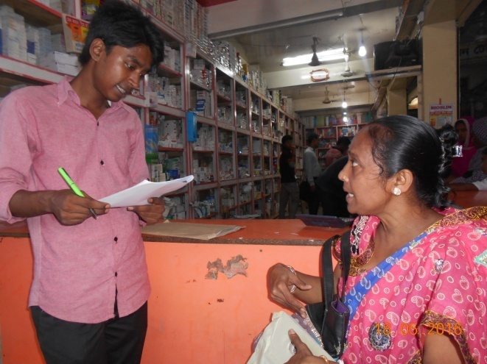 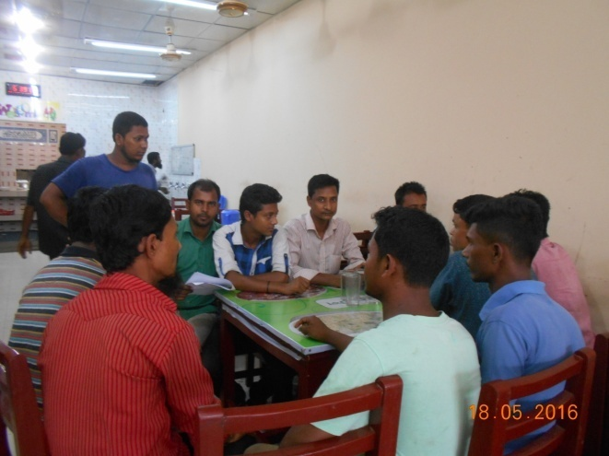

Interview of a female consumer FGD of potential consumers

**Kurigram**

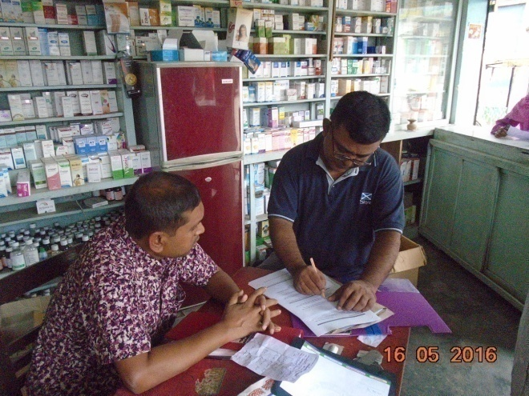 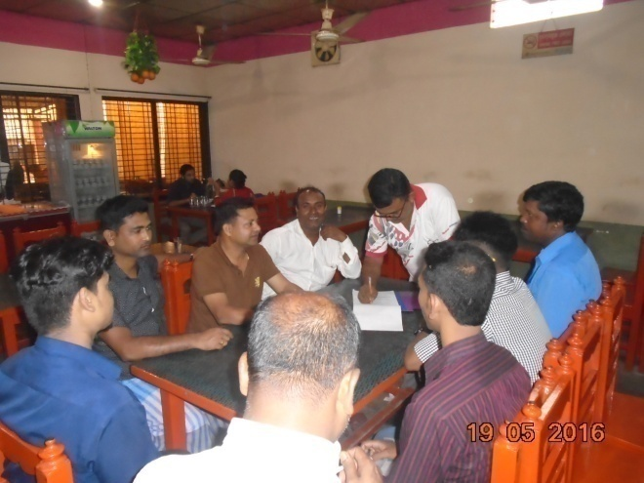

Interview of a pharmacy owner FGD of potential consumers

**Moulvi Bazar**

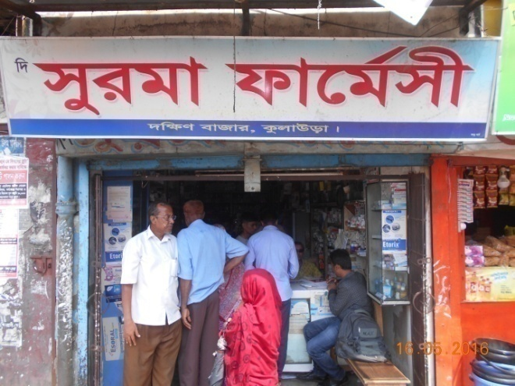 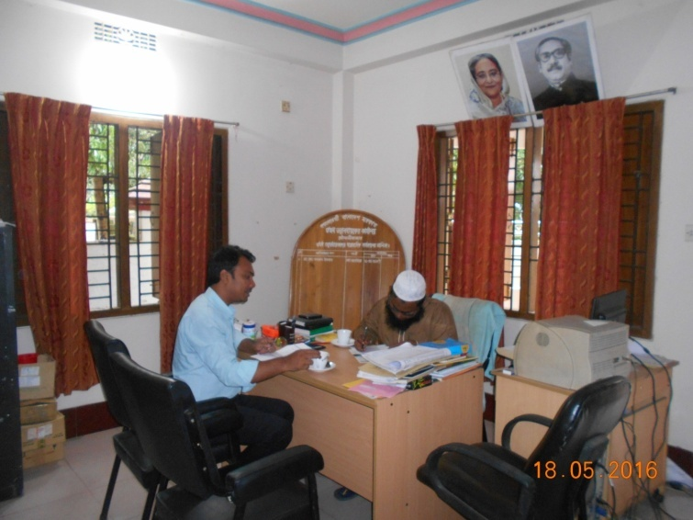

Outer view of a pharmacy Interview of a local Key Informant

**Dhaka Khilkhet**

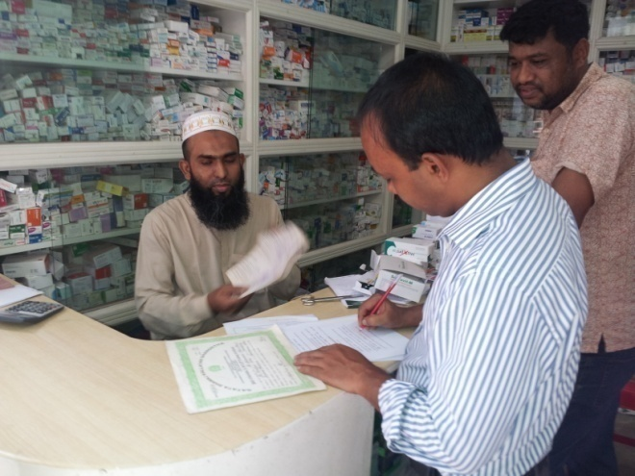 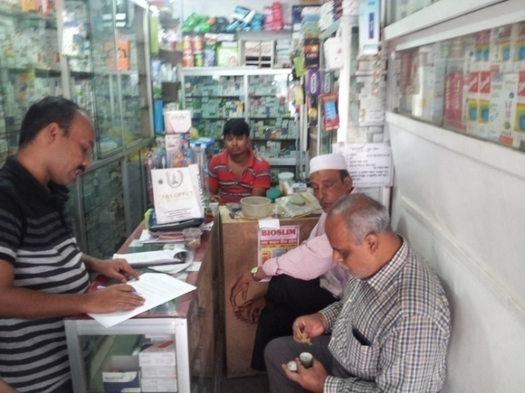

Interview of a dispenser Interview of a male consumer