Accredited Drug Shops (ADS) in Uganda: Enhancing Economic Opportunities for Women in Rural Areas and Improving Access to Family Planning Services

Class C drug shops in remote areas of Uganda are often the first point of contact for community members seeking health care advice or purchasing medicines. Regulated by the National Drug Authority (NDA), these shops are authorized to sell over-the-counter medicines. In an effort to improve access to medicines in these underserved areas, NDA in collaboration with MSH conceptualized and implemented an accredited drug seller initiative which involved transforming existing Class C drug shops into regulated, profitable Accredited Drug Shops (ADS). The conceptual framework is based on developing public-private links at the national, district, and community levels. The public sector develops and enforces standards, while providing economic incentives through the authorization of an expanded list of drugs that accredited shops can dispense. The private sector contributes to supply, shop renovations, training, and financing.

The ADS concept was first piloted in Kibaale district from 2009 to 2011. NDA developed standards for premises, personnel, record keeping and dispensing practices, and established a list of prescription medicines that could be legally dispensed by ADS. NDA and MSH trained local monitors and supportive supervision teams from the district, which were empowered to supplement NDA’s routine inspections. To become accredited, 246 drug shop attendants received training in good dispensing practices, how to handle common medical problems, patient communication, and referrals; 82 owners also received business skills training and guidance on obtaining loans from microfinance providers.

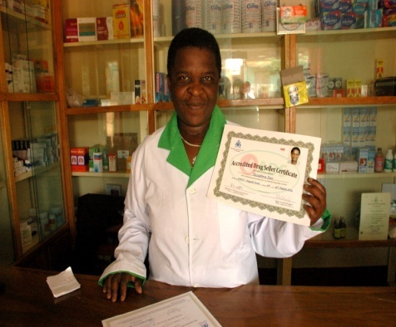
In addition to improving pharmaceutical services, the ADS program provides secure job opportunities for rural women as outlet owners and as accredited drug sellers. In Kibaale district, women comprised 71% of the ADS owners and about 87% of the ADS sellers.The ADS model in Kibaale showed that owners were able to make a profit and therefore the business was sustainable
“Our drug shops now look good. The drugs are well kept in glass shelves. We were taught how to keep the records and how to explain to our clients when we are giving drugs.”
—Jose Tusubila, ADS owner in Kagadi

Because the vast majority of the accredited drug shop attendants are women who live in the communities they serve, linking ADS shops to the provision of family planning products and maternal and child health care seems a natural fit. The STRIDES for Family Health project, funded by the US Agency for International Development, supported the expansion of the ADS initiative to the four additional districts of Kamuli, Kyenjojo, Kamwenge, and Mityana in 2012–2013. Of the 430 newly trained drug sellers in these districts, 387 (90%) are women, along with about 81% of the ADS owners in these districts.

From July-November 2012 in Kyenjojo district 56 ADS served 2,618 family planning clients: 52% received oral contraceptives, 36% got condoms, and 12% were referred for other methods of family planning.

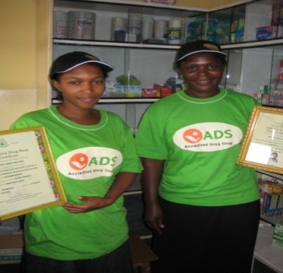
To expand sales and increase profits, ADS owners have been encouraged to stock additional items, such as cosmetics and home care products, to reduce dependence drug sales alone.

The ADS model provides an opportunity to have a positive impact on the income and health of Ugandan women.
“I used not to know stock evaluation. I could not even calculate business profitability. I would only realize I am out of stock when patients asked for the medicines. Through the business training, I am able to keep reasonable stock to serve the drug needs of my clients.”
—Rose Kitone, ADS owner in Kakumiro

